**S. Materials and methods**

S1. Total anthocyanin contents by pH-differential method

The total anthocyanin contents of the callus were measured using the pH differential method. The extracts were centrifuged at 15,000 rpm for 20 min, and the optical density of the supernatants was measured at 510 and 700 nm with a spectrophotometer (Bio-Tek, USA). Each sample was calculated according to the following formula: TAC (lg/g) = (A 9 MW 9 DF 9 103 )/e; where A = (A510 nm - A700 nm)pH1.0 - (A510 nm - A700 nm)pH4.5 (The difference in absorbency), e = the molar extinction coefficient for cyaniding-3-glucoside (26,900), MW = the molecular weight of cyaniding-3-glucoside (449.2 g/mol), and DF = the dilution factor. The absorbance of the extract was then measured at 510 nm and 700 nm. The absorbance of the extract was calculated using the formula stated below:

A = (A510 - A700) pH 1.0 - (A510 - A700) pH 4.5

The total anthocyanin content (TA) was calculated as follows:

TA = (A x MW x DF x 1000)/(ε x 1)

The result was calculated as milligram of cyanidin-3-glucoside per gram of fresh weight using a molar absorptivity (ε) of 26,900 and a molecular weight (MW) of 449.2, where DF is the dilution factor.

S1. HPLC analysis

0.2 g of the freeze-dried callus were mixed with 5 ml of ethyl acetate acid and keep it 3 hours in the shaking incubator. After that the extracts were centrifuged for 30 minutes and the supernatant were moved to a new glass tube. The same method is repeated three times. Take 500 µl of the final *Gynura procumbens* callus extracts were diluted in 500 µl methanol and filtered with Nylon Syringe Filters, 0.45 µm and keep in the HPLC vial for running the machine. 100% acetonitrile was used as a mobile phase. The flow rate was 0.7ml/min and injection volume were 10 µl. Cyanidin-monoglucoside was eluted with an isocratic condition and detected at 254nm.

S3. LC-MS analysis methods

Each 1g of the fresh callus grown under different lights were homogenized and extracted in 10 ml methanol. Chromatographic conditions were as follows: total run time 10 min; Phenomenex Kinetex C18 column (2.1 × 30 mm, 1.7 μm particle size) kept at 35°C; a binary mobile phase consisting of (A) water with 0.1% formic acid (v/v) and (B) acetonitrile with 0.1% formic acid (v/v); gradient elution of 10% B in 0 min, 10% B in 1 min, increasing to 50% B in 5 min, decreasing to 10% B in 5.1 min and 10% B in 7 min; flow rate 350 μl/min.; injection volume 5 μl; autosampler temperature 4°C.

**Table S1:** Analysis of DPPH radical scavaging activity, total phenolic contents, total flavonoids in the callus grown under different hormone concentrations

|  |  |  |  |  |
| --- | --- | --- | --- | --- |
| No. | Name | DPPH radical scavenging (%) | Total phenolic (mg/g) | Total flavonoid (µg/g) |
| 1. | MS + NAA 0.5 + BAP 2.0 | 57.90 ±2.32 | 0.97±0.03 | 0.29±0.14 |
| 2. | MS + NAA 1.0 + BAP 2.0 | 47.02 ±3.21 | 0.93±0.03 | 0.25±0.11 |
| 3. | MS + NAA 3.0 + BAP 2.0 | 48.55±2.73 | 0.86±0.02 | 0.27±0.16 |
| 4. | MS + NAA 5.0 + BAP 2.0 | 34.15±1.79 | 0.83±0.02 | 0.23±0.14 |
| 5. | MS + NAA 0.5 + Kin 2.0 | 37.68±2.03 | 0.89±97.51 | 0.19±0.00 |
| 6. | MS + NAA 1.0 + Kin 2.0 | 25.64 ±1.56 | 0.77±0.05 | 0.18±0.18 |
| 7. | MS + NAA 3.0 + Kin 2.0 | 15.59±1.82 | 0.84±0.04 | 0.14±0.18 |
| 8. | MS + NAA 5.0 + Kin 2.0 | 23.04±1.65 | 0.75±0.04 | 0.18±0.09 |
| 9. | MS + IBA 0.5 + BAP 2.0 | 40.76±2.52 | 0.94±0.03 | 0.29±0.10 |
| 10. | MS + IBA 1.0 + BAP 2.0 | 34.87±2.05 | 0.89±0.04 | 0.29±0.10 |
| 11. | MS + IBA 3.0 + BAP 2.0 | 24.71 ±2.73 | 0.83±0.05 | 0.28±0.17 |
| 12. | MS + IBA 5.0 + BAP 2.0 | 32.23±1.81 | 0.95±0.03 | 0.33±0.20 |
| 13. | MS + IBA 0.5 + Kin 2.0 | 33.33 ±1.62 | 0.95±0.04 | 0.27±0.20 |
| 14. | MS + IBA 1.0 + Kin 2.0 | 46.49 ±1.41 | 1.02±0.04 | 0.35±0.19 |
| 15. | MS + IBA 3.0 + Kin 2.0 | 29.44±1.76 | 0.85±0.04 | 0.23±0.12 |
| 16. | MS + IBA 5.0 + Kin 2.0 | 22.37 ±2.15 | 0.81±0.05 | 0.19±0.12 |

**Table S2:** Effects of plant growth regulators response on *G. procumbens* for callus induction

|  |  |  |  |  |  |
| --- | --- | --- | --- | --- | --- |
| Hormone treatments (mg/L) | Callus response | Color | Texture | Fresh weight | Dry weight |
| MS + NAA 0.5 + BAP 2.0 | +++ | Greenish white | Soft | 123.36 | 7.08 |
| MS + NAA 1.0 + BAP 2.0 | +++ | Greenish white | Soft | 119.81 | 6.94 |
| MS + NAA 3.0 + BAP 2.0 | ++ | Greenish white | Soft | 135.4 | 7.65 |
| MS + NAA 5.0 + BAP 2.0 | ++ | Greenish white | Soft | 128.65 | 7.15 |
| MS + NAA 0.5 + Kin 2.0 | + | Greenish white | Soft | 113.22 | 6.95 |
| MS + NAA 1.0 + Kin 2.0 | ++ (roots formed) | Greenish white | Soft | 132.86 | 8.05 |
| MS + NAA 3.0 + Kin 2.0 | ++ (roots formed) | Greenish white | Soft | 135.78 | 7.99 |
| MS + NAA 5.0 + Kin 2.0 | ++ (roots formed) | Greenish white | Soft | 123.9 | 7.24 |
| MS + IBA 0.5 + BAP 2.0 | + | Greenish white | Soft | 114.94 | 6.82 |
| MS + IBA 1.0 + BAP 2.0 | ++ | Greenish white | Soft | 129.73 | 7.38 |
| MS + IBA 3.0 + BAP 2.0 | ++ | Greenish white | Soft | 126.27 | 7.25 |
| MS + IBA 5.0 + BAP 2.0 | ++ | Greenish white | Soft | 140.32 | 7.98 |
| MS + IBA 0.5 + Kin 2.0 | + | Greenish white | Soft | 74.7 | 5.38 |
| MS + IBA 1.0 + Kin 2.0 | + | Greenish white | Soft | 82.26 | 5.57 |
| MS + IBA 3.0 + Kin 2.0 | +(roots formed) | Greenish white | Soft | 116.51 | 7.27 |
| MS + IBA 5.0 + Kin 2.0 | ++ (roots formed) | Greenish white | Soft | 110.56 | 6.52 |

Footnote: + represents the response of callus for PGRs combination.

**Table S3:** Effects of LED on the accumulation of total phenolic contents, total flavonoid contents, total anthocyanin contents and antioxidant activity in *Gynura procumbens* callus.

|  |  |  |  |  |
| --- | --- | --- | --- | --- |
| Sample | Dark | Blue | White | Red |
| TPC (mg GAE/g dry extracts) | 1.05±0.05 a | 1.19 ±0.04 b | 1.04± 0.03 a | 1.05± 0.06 a |
| TFC (mg CAT/g dry extracts) | 2.77±0.12 a | 3.37±0.07 b | 3.34± 0.01 b | 3.34±0.09 b |
| TAC (mg/g) | 3.18±0.70 a | 8.69 ±1.17 b | 6.86±0.69 bc | 4.71±2.89 ac |
| DPPH (%) | 53.34 ±6.16 a | 59.85 ±3.89 a | 59.64±4.45 a | 54.63±4.16 a |

Here, ordinary one-way ANOVA, Tukey's multiple comparisons test was performed with p < 0.05s as significant and the different letters denote for their significances with each other.

**Table S4:** HPLC conditions for the analysis of cyanidin-monoglucosides in *Gynura procumbens*

|  |  |
| --- | --- |
| Instrument | Shimadzu HPLC System (CBM-20A, LC-20A, SPD-20AD, and CTO-20A, Japan) |
| Column | C18 |
| Column temperature | 35 ℃ |
| Mobile phase | Solvent Name; 100% Acetonitrile |
| Flow rate | 0.7ml/min |
| Injection volume | 10 µl |
| UV wavelength | 254 nm |
| Run time | 25 mins |

**Table S5:** The observation of the differences between the extraction of fresh and dried callus on the yield of cyanidin-mnoglucosides

|  |  |  |  |  |
| --- | --- | --- | --- | --- |
| Colors | Retention time (dry) | Areas (dried) | Retention time (fresh) | Areas (fresh) |
| Dark Dark | 4.786 | 16389375 | 4.597 | 656908 |
| Blue Blue | 4.742 | 14866900 | 4.658 | 1514037 |
| White White | 4.84 | 7597326 | 4.685 | 1060612 |
| Red Red | 4.737 | 13632654 | 4.611 | 645721 |

**Table S6:** LC-MS analysis of cyanidin-monoglucoside contents in *Gynura procumbens* callus grown under different LED lights

|  |  |  |  |  |
| --- | --- | --- | --- | --- |
| Name | RT | Area | Ppb (ng/ml) | ng/g |
| Cyanidin-monoglucoside | 1.66 | 1199.840 | 1.105 | - |
| Callus dark | 1.66 | 152.216 | 0.426 | 4.26 |
| Callus blue | 1.66 | 468.987 | 0.629 | 6.29 |
| Callus white | 1.65 | 421.507 | 0.598 | 5.98 |
| Callus red | 1.65 | 239.087 | 0.480 | 4.80 |

**Table S7:** LC-MS condition for the analysis of cyanidin-monoglucosides in *Gynura procumbens*

|  |  |
| --- | --- |
| Instrument | XEVO-TQS#WAA250 |
| Column | C18 |
| Sample Temperature: | 12 ℃ |
| Column temperature | 35 ℃ |
| Mobile phase | Solvent Name A: 0.1% formic acid in Water  Solvent Name B: 0.1% formic acid in Acetonitrile |
| Gradient | Time(min) Flow Rate %A %B Curve  1. Initial 0.500 95.0 5.0 Initial  2. 0.50 0.500 95.0 5.0 6  3. 4.00 0.500 0.0 100.0 6  4. 4.50 0.500 0.0 100.0 6  5. 5.00 0.500 95.0 5.0 6  6. 10.00 0.500 95.0 5.0 6 |
| Flow rate | 1ml/min |
| Injection volume | 5 µl |
| UV wavelength | 530 nm |
| Polarity, scan type | - |
| Ionization source | ES+ |
| Mass scan range | - |
| Run time | 10 mins |



**Figure S1:** Effect of various plant growth regulator combinations on callus culture for (A) DPPH free radical scavenging activity (B) TFC and (C) TPC. Values are shown in mean ± standard deviation (SD) from three replicates (n=3). Ordinary one-way ANOVA Dunnett's multiple comparisons test was performed where P<0.05, P<0.01, P<0.001, P<0.0001, are represented as *,**,*** and ****, respectively.

**1.** NAA 0.5 + BAP 2.0, **2.** NAA 1.0 + BAP 2.0, **3.** NAA 3.0 + BAP 2.0, **4.** NAA 5.0 + BAP 2.0, **5.** NAA 0.5 + Kn 2.0, **6.** NAA 1.0 + Kn 2.0, **7.** NAA 3.0 + Kn 2.0, **8.** NAA 5.0 + Kn 2.0, **9.** IBA 0.5 + BAP 2.0, **10.** IBA 1.0 + BAP 2.0, **11.** IBA 3.0 + BAP 2.0, **12.** IBA 5.0 + BAP 2.0, **13.** IBA 0.5 + Kn 2.0, **14.** IBA 1.0 + Kn 2.0, **15.** IBA 3.0 + Kn 2.0, **16.** IBA 5.0 + Kn 2.0



**Figure S2:** HPLC profile standard curve of cyanidin-monoglucosides

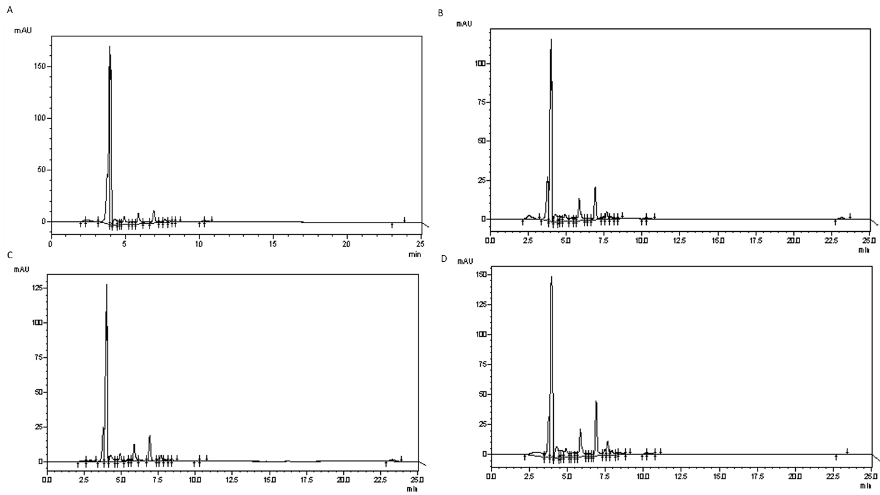

**Figure S3:** HPLC peaks for *Gynura procumbens* callus grown in (A) dark, (B) blue, (C) white and (D) red



**Figure S4:** Comparative peak area covered by Freeze dried and fresh callus extract grown in LEDs; analyzed by HPLC.

First the callus from freeze dried and fresh calli were extracted and run with HPLC. The dried callus extract showed significantly higher concentration.

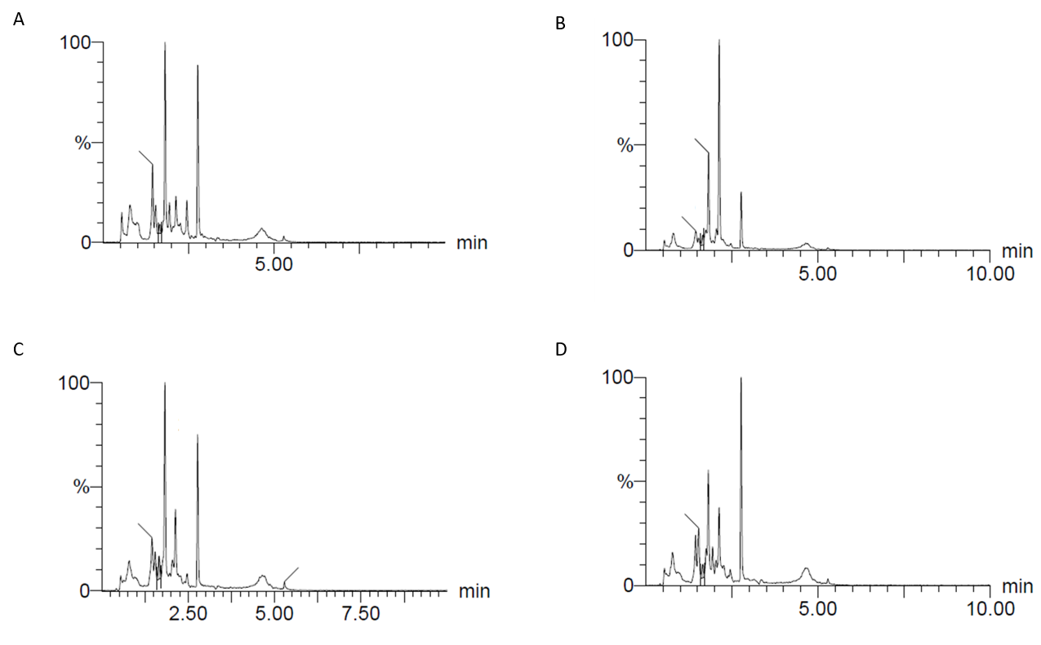

**Figure S5:** LC-MS peaks of cyanidin-monoglucoside content in *Gynura procumbens* callus grown in (A) dark, (B) blue, (C) white and (D) red

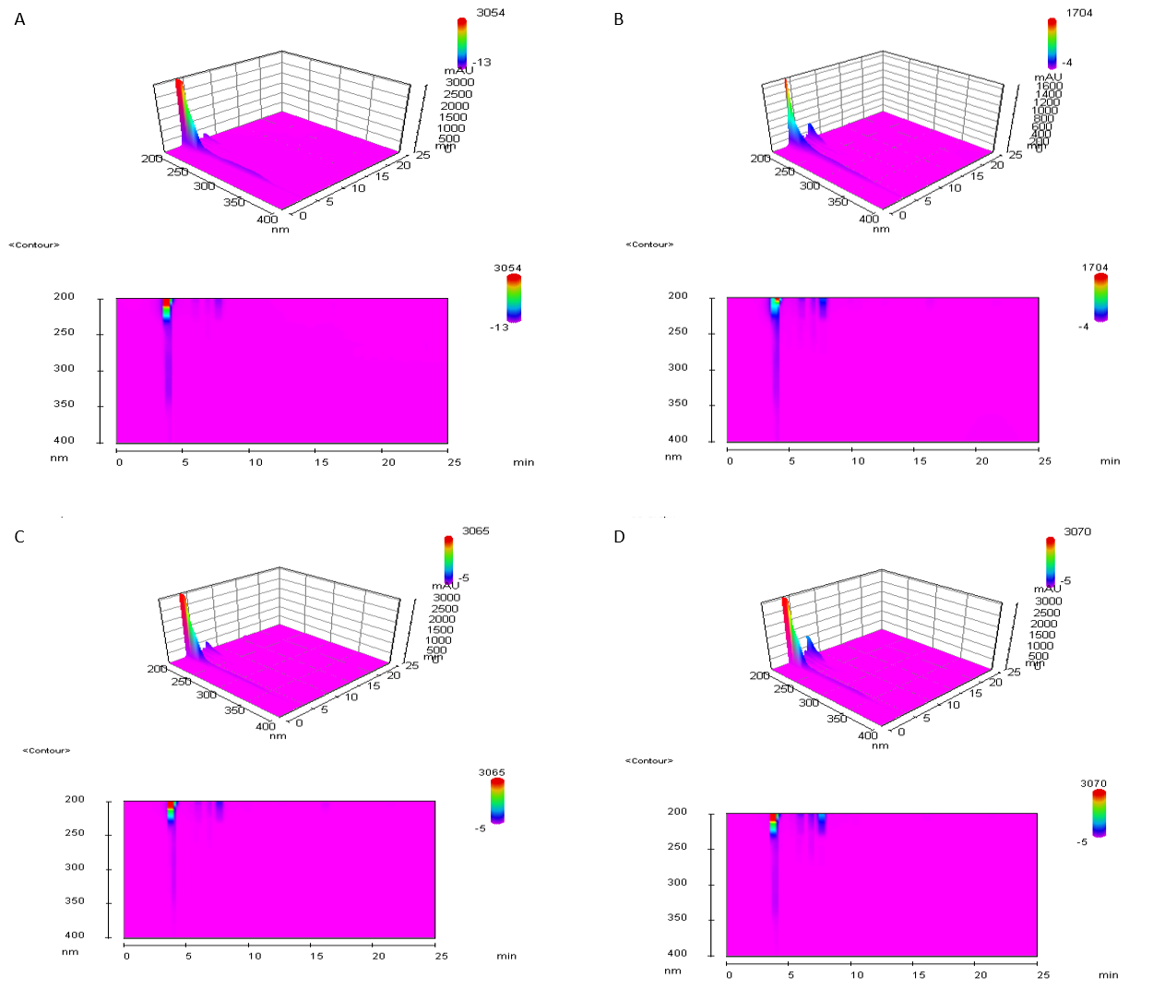

**Figure S6:** HPLC analysis on 3D capture of cyanidin-monoglucosides content in *Gynura procumbens* callus culture in (A) Dark, (B) Blue, (C) White and (D) Red