Figures

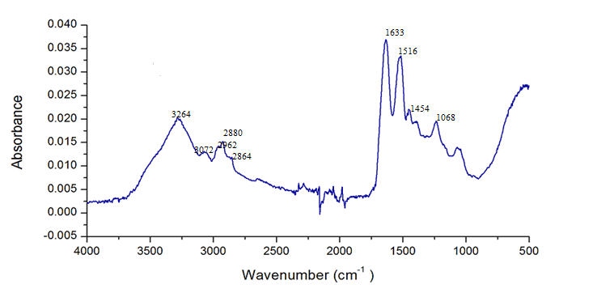
Figure 1 Average FTIR-ATR Spectrum of healthy Human Scalp Hair tissue

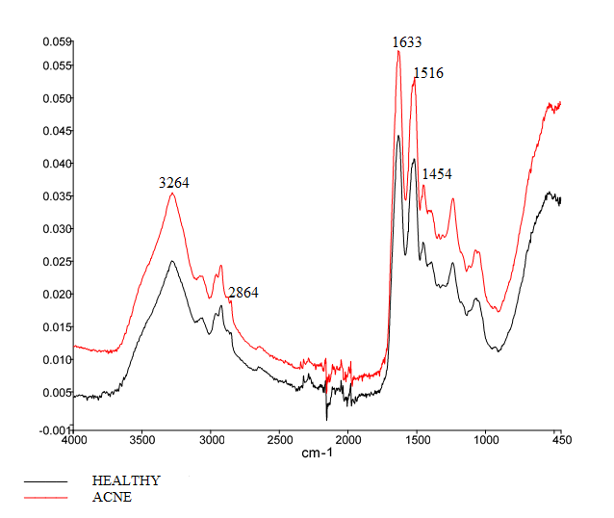
Figure 2 Overlaid Average FTIR-ATR Spectra of Healthy and Acne Vulgaris Human Scalp Hair tissues

Figure 3. Histogram Indicating the Mean Intensity Ratios of Healthy and Acne Vulgaris
Hair tissues

Fig 4. Group Statistics T-Test of Hair tissue of Healthy and Acne Vulgaris tissues

