Supplementary materials

3D-QSAR, molecular docking, and molecular dynamics simulation study of thieno[3,2-b]pyrrole-5- carboxamide derivatives as LSD1 inhibitors
Yongtao Xu^{1,2,3}, Zihao He^{1,2,3}, Min Yang^{1,2,3}, Hongyi Liu^{1,2,3}, Xiaoyuan Lu¹, Songjie Zhang^{1,2,3} , Meilan Huang⁴
- School of Biomedical Engineering, Xinxiang Medical University, Xinxiang, Henan, 453003, China
- Xinxiang key laboratory of biomedical information research
- Henan engineering laboratory of combinatorial technique for clinical and biomedical big data
- School of Chemistry and Chemical Engineering, Queen's University Belfast, David Keir Building, Stranmillis Road, Belfast, Northern Ireland, United Kingdom

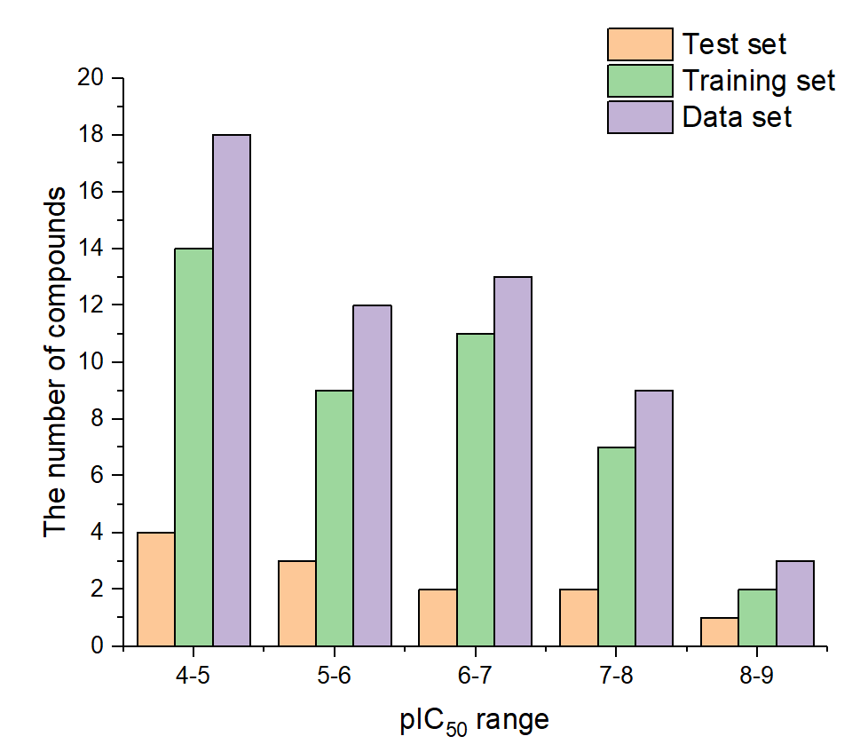
Fig. S1. 3D-QSAR Histogram of activity data distribution

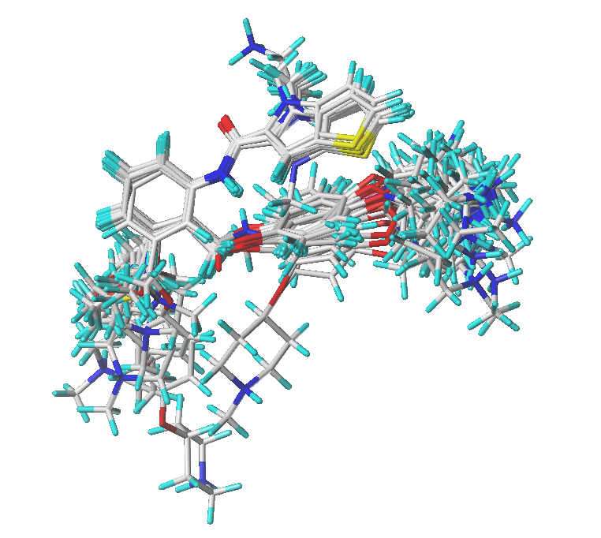
Fig S2. Docking-based alignment of training set compounds

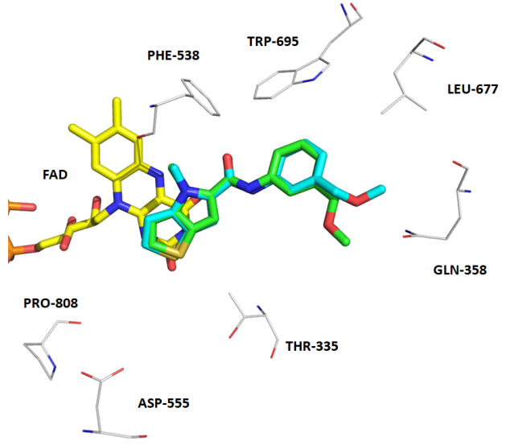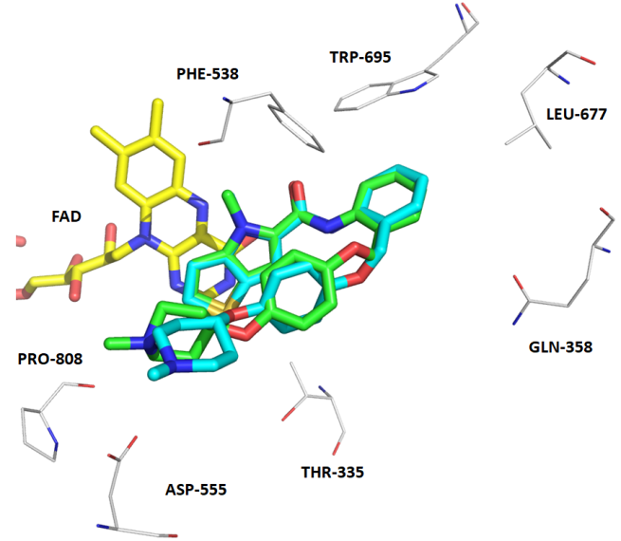
B
A
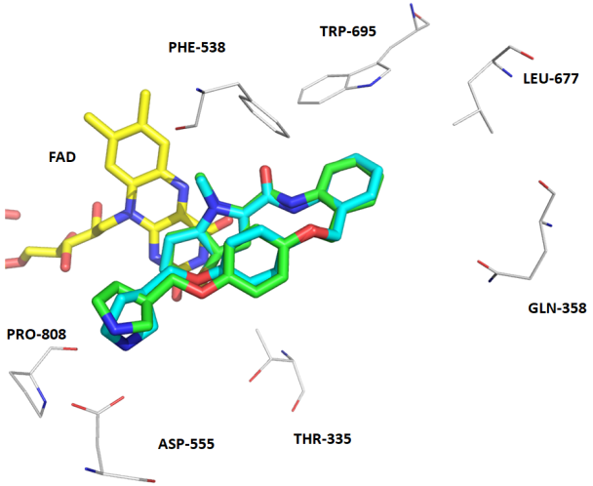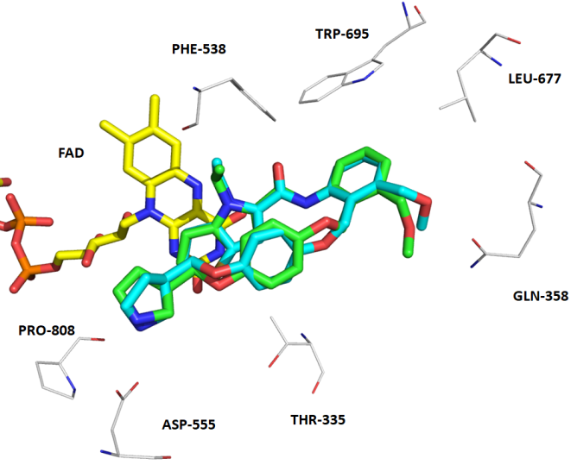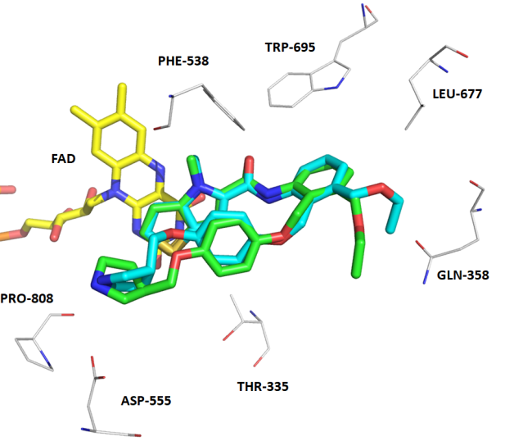
E
D
C
Fig. S3. Figures A, B, C, D, and E show the superposition of the crystal pose of the compounds (green) (PDB: 5LGN, 5LGT, 5LGU, 5LHH, 5LHI), and the docked pose of the compounds (cyan), respectively, and the FAD as a reference for orientation is shown in yellow.
Table S1. Randomizations of biological activity for the Y-random test.
Random_1 | Random_2 | Random_3 | Random_4 | Random_5 | Random_6 | Random_7 | Random_8 | Random_9 | Random_10
4.873 | 6.346 | 4.166 | 5.538 | 6.171 | 8.108 | 4.318 | 8.174 | 8.174 | 4.728
4.777 | 6.209 | 6.752 | 7.745 | 6.095 | 8.174 | 4.599 | 8.108 | 7.194 | 4.873
4.599 | 6.171 | 5.538 | 5.886 | 5.886 | 7.194 | 4.281 | 7.745 | 4.166 | 6.171
4.281 | 8.174 | 7.745 | 7.252 | 8.108 | 4.166 | 4.166 | 7.194 | 4.777 | 7.187
7.535 | 4.529 | 7.194 | 7.187 | 7.745 | 4.281 | 7.194 | 6.79 | 4.411 | 5.131
7.067 | 5.658 | 5.027 | 7.18 | 7.194 | 4.599 | 8.174 | 6.752 | 4.048 | 4.599
8.174 | 5.131 | 6.355 | 7.535 | 4.728 | 4.318 | 8.108 | 6.509 | 5.032 | 4.318
8.108 | 4.873 | 4.728 | 7.067 | 7.535 | 5.032 | 5.131 | 6.355 | 4.318 | 5.032
5.602 | 4.777 | 8.108 | 5.131 | 7.067 | 4.048 | 4.873 | 5.824 | 4.599 | 4.048
5.131 | 4.599 | 6.209 | 4.873 | 5.658 | 4.411 | 4.728 | 5.658 | 4.281 | 4.411
5.658 | 4.281 | 6.171 | 7.194 | 8.174 | 4.777 | 4.668 | 5.602 | 8.108 | 4.777
6.509 | 5.027 | 6.095 | 6.917 | 5.602 | 4.654 | 4.654 | 5.538 | 4.654 | 4.654
4.166 | 5.602 | 5.886 | 6.827 | 5.538 | 4.668 | 4.777 | 5.131 | 4.668 | 6.346
6.752 | 5.538 | 7.187 | 6.68 | 6.917 | 4.728 | 4.411 | 5.032 | 4.728 | 6.68
5.824 | 7.745 | 5.658 | 6.346 | 7.252 | 4.873 | 4.048 | 5.027 | 4.873 | 6.827
5.886 | 7.18 | 5.602 | 6.209 | 7.187 | 5.131 | 5.032 | 4.873 | 5.131 | 6.917
7.252 | 7.535 | 6.346 | 8.174 | 6.209 | 5.658 | 6.752 | 4.777 | 5.658 | 4.668
7.187 | 7.067 | 4.048 | 6.171 | 6.827 | 4.529 | 5.824 | 4.728 | 4.529 | 6.752
6.917 | 4.318 | 5.032 | 6.095 | 6.68 | 4.577 | 5.658 | 4.668 | 4.577 | 6.209
6.827 | 4.728 | 4.318 | 8.108 | 6.346 | 6.509 | 5.602 | 4.654 | 6.509 | 8.108
6.68 | 4.668 | 7.18 | 4.281 | 5.658 | 6.355 | 5.538 | 4.599 | 6.68 | 8.174
6.346 | 8.108 | 7.535 | 4.411 | 5.131 | 6.79 | 7.745 | 4.577 | 6.346 | 7.194
6.209 | 6.095 | 7.067 | 4.048 | 4.281 | 4.046 | 5.027 | 4.529 | 6.209 | 4.166
7.18 | 5.886 | 8.174 | 5.032 | 5.032 | 5.027 | 4.046 | 4.411 | 6.752 | 4.281
7.194 | 7.252 | 6.917 | 5.027 | 4.318 | 7.745 | 6.79 | 4.318 | 5.824 | 7.067
4.529 | 7.187 | 4.529 | 4.166 | 7.18 | 5.538 | 6.355 | 7.535 | 5.658 | 5.886
6.171 | 4.046 | 5.658 | 4.577 | 5.027 | 5.602 | 6.509 | 7.252 | 5.602 | 6.095
6.095 | 6.79 | 5.131 | 6.509 | 4.411 | 5.658 | 4.577 | 7.187 | 5.538 | 7.252
4.411 | 6.355 | 6.509 | 4.046 | 4.048 | 5.824 | 4.529 | 7.18 | 7.745 | 7.535
4.048 | 6.509 | 4.046 | 4.318 | 6.79 | 6.752 | 5.658 | 7.067 | 5.027 | 7.18
5.032 | 7.194 | 4.411 | 5.658 | 4.668 | 6.209 | 7.18 | 6.917 | 4.046 | 5.658
4.318 | 5.824 | 4.281 | 5.602 | 4.654 | 6.346 | 7.535 | 6.827 | 6.79 | 4.529
4.728 | 5.658 | 5.824 | 6.79 | 4.577 | 6.68 | 7.252 | 6.68 | 6.355 | 4.577
4.046 | 6.752 | 6.79 | 6.355 | 4.529 | 6.827 | 7.187 | 6.346 | 6.827 | 6.509
6.79 | 6.917 | 4.577 | 6.752 | 4.046 | 6.917 | 6.171 | 6.209 | 6.917 | 6.355
6.355 | 6.827 | 4.873 | 5.824 | 4.166 | 7.067 | 6.095 | 6.171 | 7.067 | 6.79
5.538 | 6.68 | 4.777 | 4.728 | 6.752 | 5.886 | 5.886 | 6.095 | 5.886 | 4.046
7.745 | 5.032 | 4.599 | 4.668 | 4.873 | 6.095 | 7.067 | 5.886 | 6.095 | 5.027
5.658 | 4.654 | 7.252 | 4.654 | 6.355 | 6.171 | 6.917 | 5.658 | 6.171 | 7.745
5.027 | 4.577 | 6.827 | 4.777 | 6.509 | 7.187 | 6.827 | 4.281 | 7.187 | 5.538
4.668 | 4.411 | 6.68 | 4.529 | 4.777 | 7.252 | 6.68 | 4.166 | 7.252 | 5.602
4.654 | 4.048 | 4.668 | 5.658 | 4.599 | 7.535 | 6.346 | 4.048 | 7.535 | 5.658
4.577 | 4.166 | 4.654 | 4.599 | 5.824 | 7.18 | 6.209 | 4.046 | 7.18 | 5.824

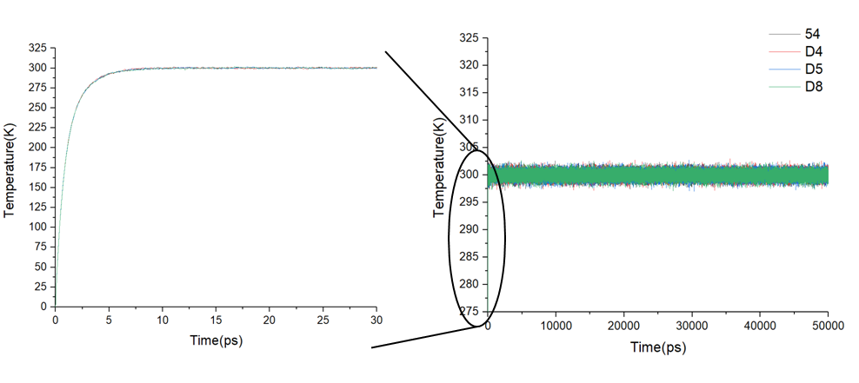
Fig. S4. Temperature fluctuation plot in MD

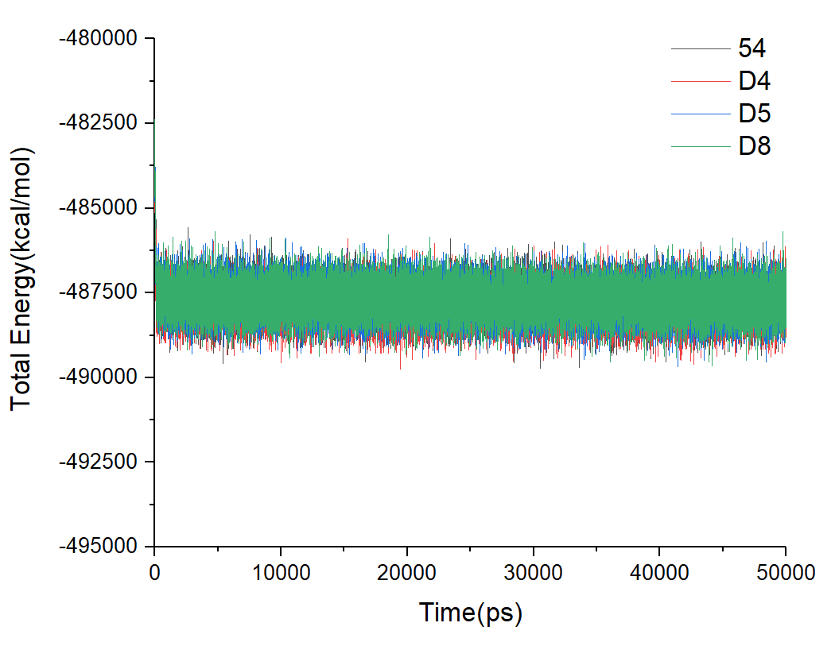
Fig. S5. Total energy fluctuation plot in MD

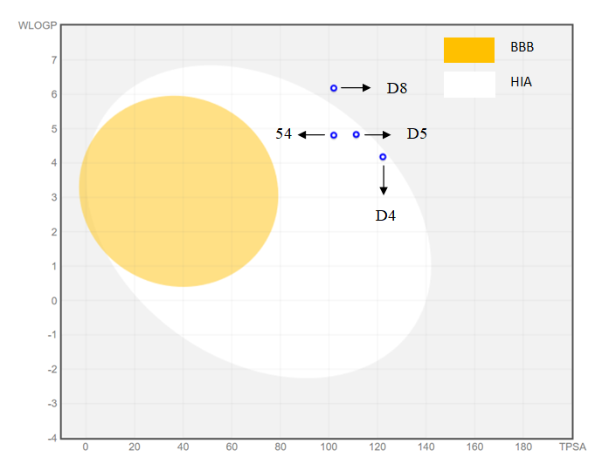
Fig. S6. BOILED-Egg model plot

