Structure-function correlations in sputter deposited gold/fluorocarbon multilayers for tuning optical response
Pallavi Pandit^{1*}, Matthias Schwartzkopf¹, André Rothkirch¹, Stephan V. Roth^{1, 2}, Sigrid Bernstorff³ and Ajay Gupta⁴
¹ Deutsches Elektronen-Synchrotron (DESY), Notkestraße 85, D-22607 Hamburg, Germany
²KTH Royal Institute of Technology, Department of Fibre and Polymer Technology, Teknikringen 56-58, SE-100 44 Stockholm, Sweden
³Elettra-Sincrotrone Trieste, SS 14, Km 163.5, I-34149 Basovizza, Trieste, Italy
⁴Center for Spintronic Materials, Amity University, UP Noida 201 313, India
pallavi.pandit@desy.de
agupta2@amity.edu
General:
Different Au/ polymer multilayer structure have been prepared by varying the Au volume fraction. The volume fraction of Au in PPFC has been calculated for a fixed filling factor (taken from literature[1]) using the following equations. The calculated values for three MLs have been listed in Table (S1).
Filling factor (F):
$$ff=\frac{ρ-ρ_{p}}{ρ_{m}-ρ_{p}} (1)$$
here, $ρ$ is the density of nanocomposite and $ρ_{p},$ $ρ_{m}$ are the densities of the polymer and metal, respectively.
Composite density: ρ = $m/v$
$$ρ= \frac{m_{m}+m_{p}}{V_{m}+V_{p}} (2)$$
where $V_{p}$ ${ and m}_{p}$ is volume and mass of the polymer and $V_{m}$ ${ and m}_{m}$ are the volume and mass of the metal.
Volume fraction:
$$\frac{V_{m}}{V_{p}}= \frac{ρ-ρ_{p}}{ρ_{m}-ρ} (3)$$

Table S1: Filling factor, density of composite and volume fraction from the 3 MLs.
Multilayer | $$ff$$ | ρ  g/cm³ | $$φ= {V_{m}}/{V_{p}}$$
Au/PPFC_1  Au/PPFC_2  Au/PPFC_3 | 0.12  0.27  0.38 | 3.19±0.1  4.44  5.35 | 0.13±0.02  0.37  0.61

Schematic sketch of sample preparation through sputtering technique:
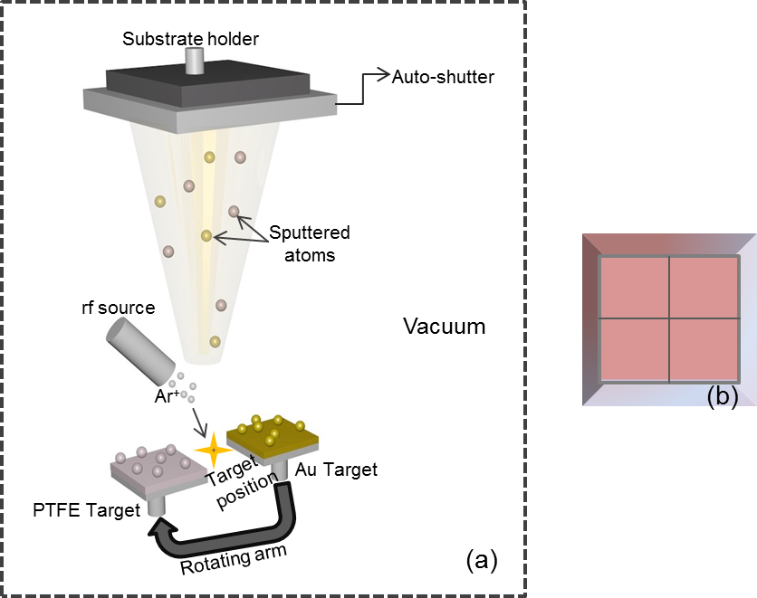

Figure S1 a) Schematic diagram of alternate sputter deposition of Au and PPFC. A rotating arm was used to switch the target. Target position was fixed in forward direction of ion beam. An auto shutter was used to cover the substrate surface during change of targets and b) Prepared sample of size of 50 $×$ 50 mm², the most uniform region in the middle 40 $×$ 40 mm² has been cut and used for various measurement.

Sketch of detector positioned used for the experiment:
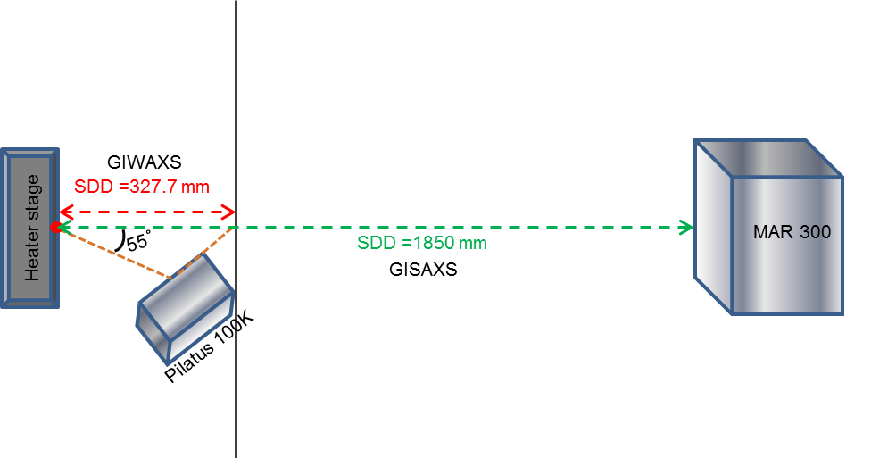
Figure S2: The sketch above illustrates the angles and the distance used in GISAXS/GIWAXS experiment at Elettra BL 5.2.

Experimental setup at Elettra, BL 5.2:
Schematic setup arrangement used for combined GISAXS and GIWAXS measurement at SAXS beamline (BL 5.2), Elettra, Trieste.
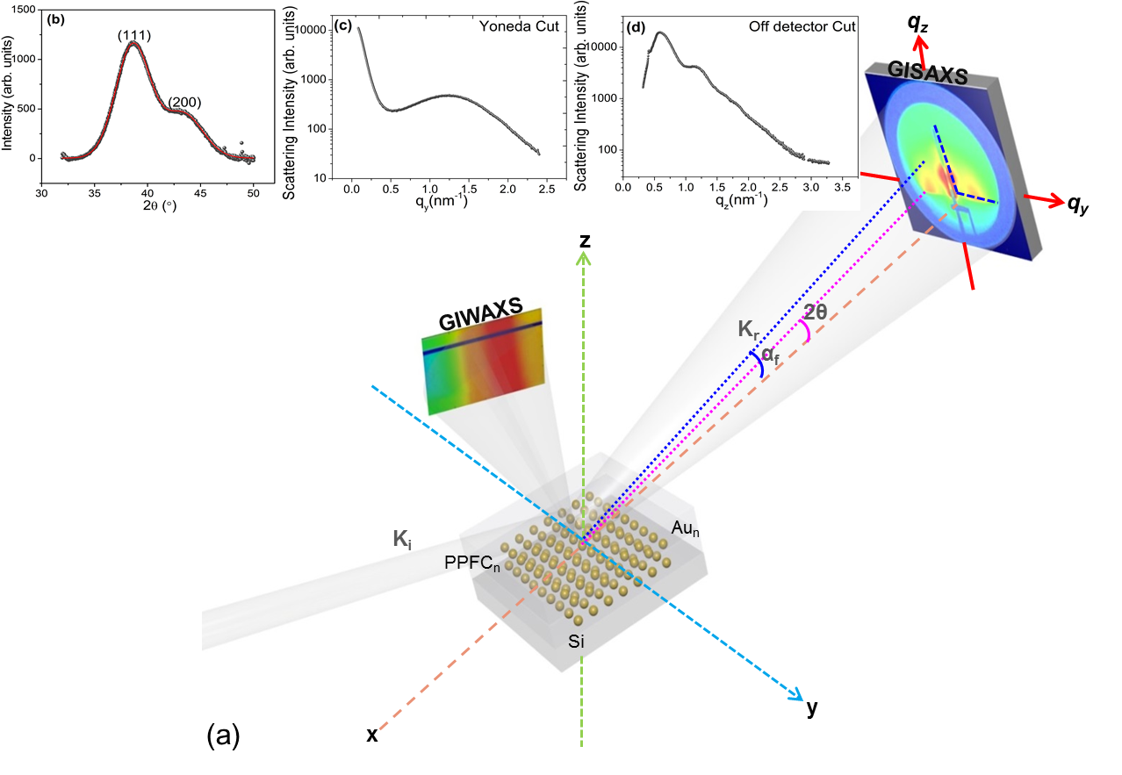
Figure S3: (a) Schematic view of the GISAXS experiment combined with In-plane-GIWAXS; (b) the extracted 1D GIWAXS profile taken as line cut as indicated in the 2D GIWAXS image, (c) Yoneda cut (q_{y} = 0.236) and (d) off-detector cut (along q_{z}) an
as indicated by blue dashed lines in 2D GISAXS pattern. In the GISAXS pattern the origin of the coordinates of q_{y} and q_{z} is indicated by the direct beam position.

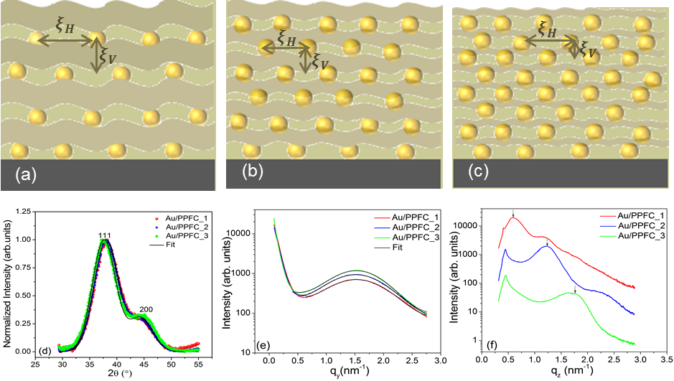
Figure S4: Schematic structure presentations of the three MLs a) Si/[Au(1nm)/PPFC (19nm)], b) Si/[Au(1nm)/PPFC (9nm)] and c) Si/[Au(1nm)/PPFC (5.6nm)], the layer waviness is because of Au inclusion in PPFC matrix , d) Normalized 1D GIWAXS pattern of three pristine MLs and black lines represent their corresponding fit result (black line), e) GISAXS 1D pattern of pristine MLs as a function of q_{y,} and f) The off-detector cuts of the three pristine MLs shifted vertically for better visibility of the individual features.

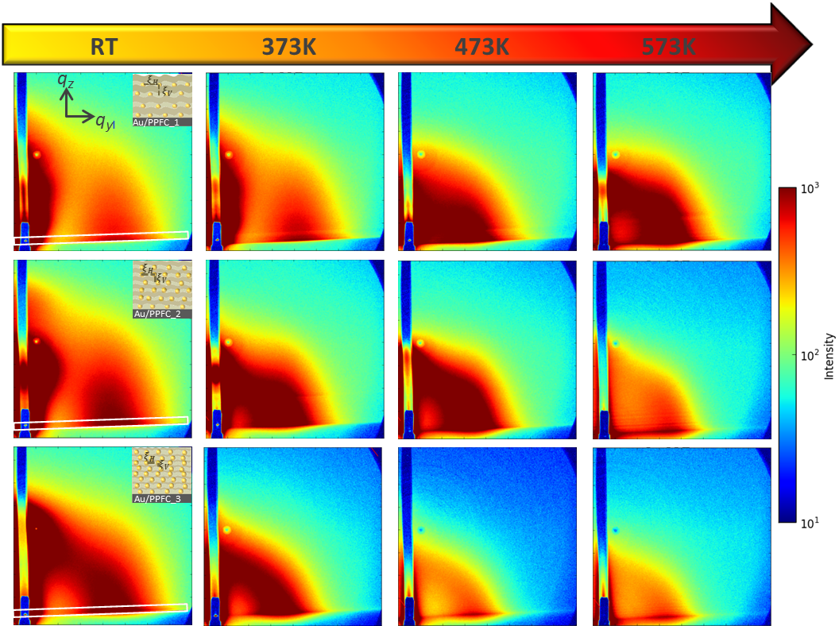
Figure S5: GISAXS pattern of MLs (a) Au/PPFC_1, (b) Au/PPFC_2 and (c) Au/PPFC_3 at the indicated temperatures. The white rectangle in all three ML’s room temperature pattern is showing the projected area chosen to extract structural lateral features after applying 2˚ tilt correction. The inset of GISAXS room temperature images of 3 MLs is showing the schematic layer arrangement and their horizontal and vertical order $ξ_{H}$ and $ξ_{V}$.

IsGISAXS simulation:
A simulation of the GISAXS patterns of the sample Au/PPFC_1 was performed using the software IsGISAXS[2]. Its result was used as reference in further calculations since the morphology and structure in each individual layer of the multilayer (ML) system is identical. Modeling was limited to lateral correlations and the system Si/[Au(1 nm)/PPFC(19 nm)], .i.e the bottommost layer comparable to the Au/PPFC_1 using Distorted Wave Born approximation DWBA. We used a 1D paracrystal interference function with a distance $ξ_{H}$= 4.3± 0.05 nm and a disorder factor ω/$ξ_{H}$= 0.33. We used the Local mono-disperse approximation (LMA) and lognormal distribution in radius with σ=1.08 and R_{min} = 1.2 nm and R_{max}= 2 nm. Incident angle and wavelength were set according to the experimental values. $δ$ and β of the complex index of refraction $η= δ+iβ$ of the different materials involved are given below.

Material | Layer thickness (nm) | $$δ$$ | β | RMS roughness
Si_substrate  Au  PPFC | 5  1  19 | 7.6462 $×$ 10⁻⁶  4.7559$×10$⁻⁵  6.8741$×10$⁻⁶ | 1.7567$×10$⁻⁷  4.9278$×10$⁻⁶  3.45972$×$10⁻⁸ | 2
This model assumption allowed for correlating the side maximum in q_{y-}space with a real-space distance $ξ_{H}$ and subsequently to apply the spherical geometrical model, based on a modification using spherical particles in geometrical model by Schwartzkopf et al.[3]
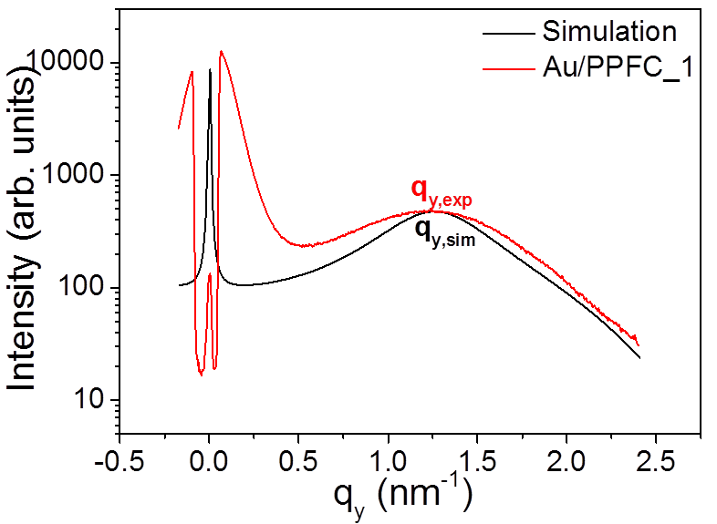
Figure S6. Comparison of simulated and experimental GISAXS pattern for Si[Au(1nm)/PPFC(19nm)]. The simulation data were scaled to the intensity of the side maximum in the experimental data.
In figure S6, the side peak position and fall-off of the curve at higher q_{y}-values due to the shape of the NP are well produced. Discrepancies at small q_{y}-value stem from the fact that only one single layer system could be simulated and experimental resolution was not included. Nonetheless, this simulation allows for quantitatively extracting the maximum values and to verify the use of the modified geometrical model by Schwartzkopf [3]. The position of the side maximum q_{y,exp} in the experimental data was extracted by fitting a Gaussian function yields the real-space length $ξ_{H,exp}=\frac{2π}{q_{y,exp}}$ (~4.7 nm in this case). From the simulation, $ξ_{H, sim}=\frac{2π}{q_{y,sim}}$ (in this case ~4.3 nm) was calculated, thus allowing to refine the real-space length scale taking into account refraction/reflection effects This allows for directly relating the position of the side maximum in q_{y}-space to the real-space interparticle distance obtained by simulation and shows that the real-space length scale is reduced by the refinement factor 4.3/4.7. The position of the side maximum was extracted for all other samples at various temperatures using accordingly DPDAK [4] (Gaussian fit) and the real space interparticle distance was refined based on results from simulation reference and the refinement factor. This procedure allows for the rapid analysis of GISAXS data taking the refraction/reflection effects into the account.
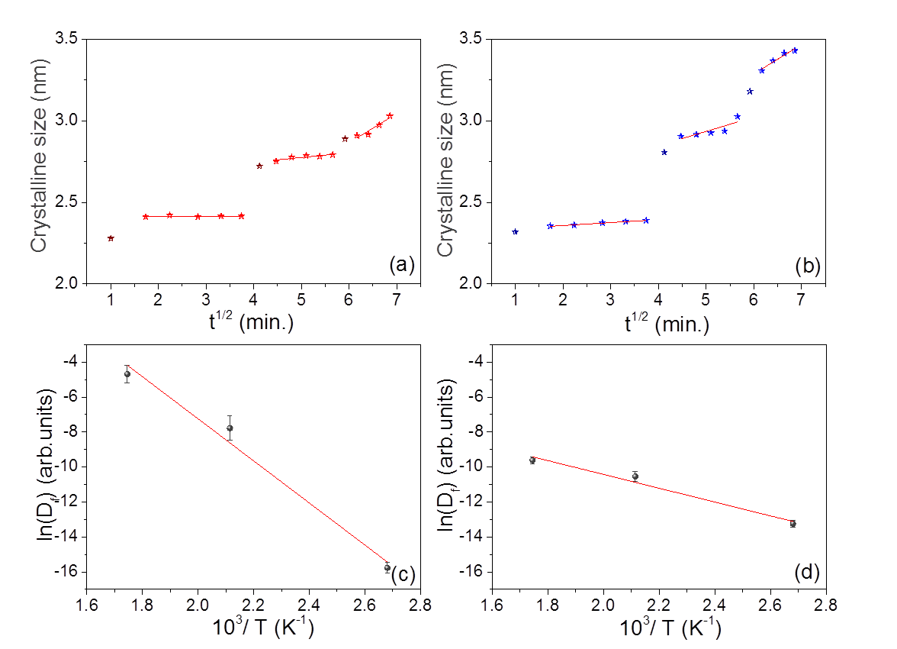
Figure S7: Minimum crystalline size variation with time and temperature in three MLs a)Au_PPFC_1, b) Au_PPFC_2 and their corresponding Arrhenius-plot c) Au_PPFC_1, d) Au_PPFC_2.

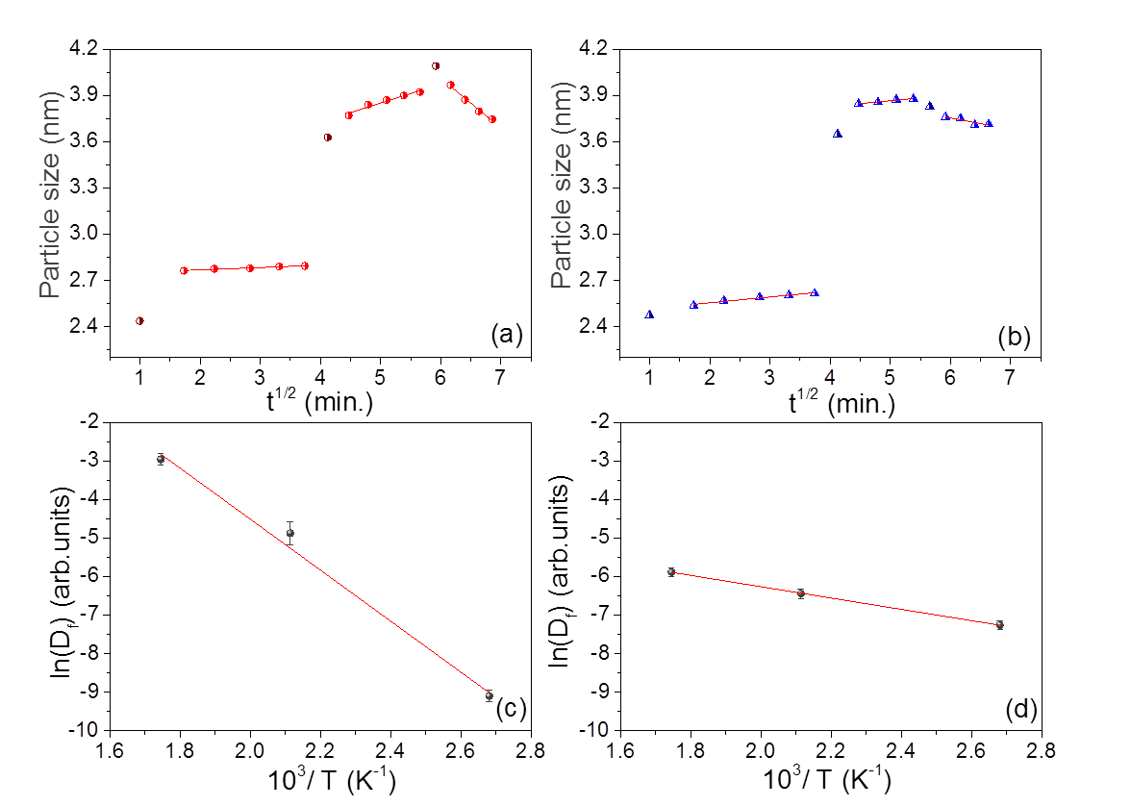
Figure S8: Particle size variation with time and temperature in three MLs a)Au_PPFC_1, b) Au_PPFC_2 and their corresponding Arrhenius-plot c) Au_PPFC_1. and d) Au_PPFC_2.

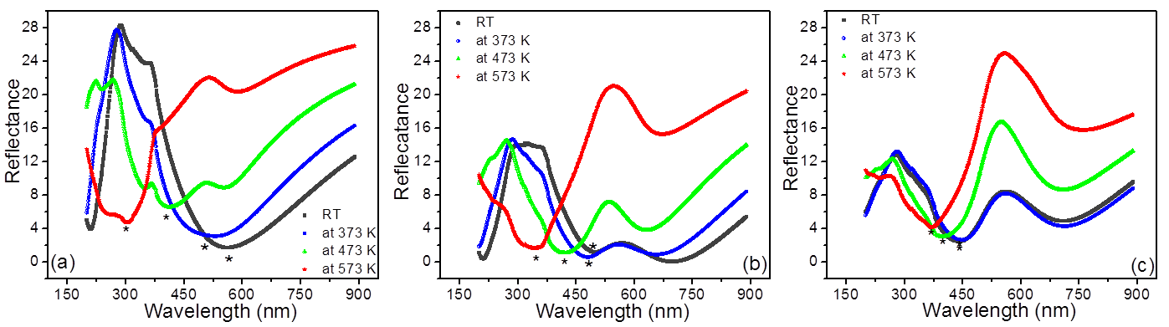

Figure S9: UV-Vis reflectance spectra of Au/PPFC_1 (a), Au/PPFC_2 (b) and Au/PPFC_3 (c) at different temperatures. LSPR positions in three MLs are indicated by symbol (*).

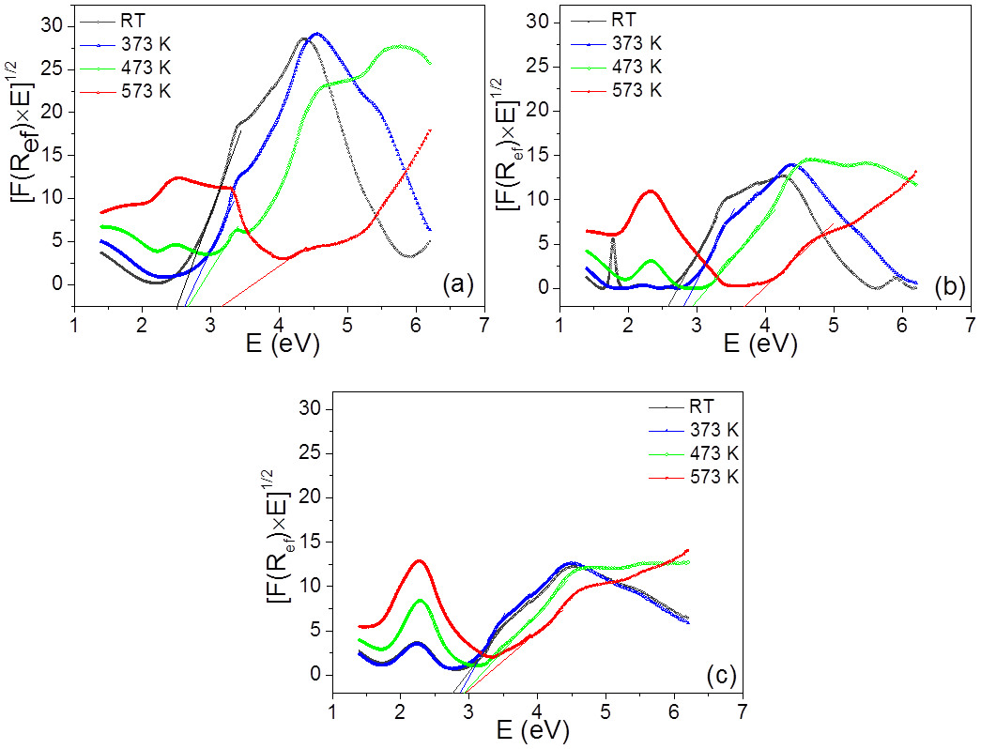

Figure S10: F(R_{ef})×(h*ν)^{1/2} as a function of photon energy for a)Au/PPFC_1, b)Au/PPFC_2 and c)Au/PPFC_3 at varying temperature.

References:
1. Takele, H.; Jebril, S.; Strunskus, T.; Zaporojchenko, V.; Adelung, R.; Faupel, F. Tuning of electrical and structural properties of metal-polymer nanocomposite films prepared by co-evaporation technique. Applied Physics A: Materials Science and Processing 2008, 92, 345–350.
2. Lazzari, R. IsGISAXS: A program for grazing-incidence small-angle X-ray scattering analysis of supported islands. Journal of Applied Crystallography 2002, 35, 406–421.
3. Schwartzkopf, M.; Buffet, A.; Körstgens, V.; Metwalli, E.; Schlage, K.; Benecke, G.; Perlich, J.; Rawolle, M.; Rothkirch, A.; Heidmann, B.; et al. From atoms to layers: in situ gold cluster growth kinetics during sputter deposition. Nanoscale 2013, 5, 5053.
4. Benecke, G.; Wagermaier, W.; Li, C.; Schwartzkopf, M.; Flucke, G.; Hoerth, R.; Zizak, I.; Burghammer, M.; Metwalli, E.; Müller-Buschbaum, P.; et al. A customizable software for fast reduction and analysis of large X-ray scattering data sets: Applications of the new DPDAK package to small-angle X-ray scattering and grazing-incidence small-angle X-ray scattering. Journal of Applied Crystallography 2014, 47, 1797–1803.

