Figure S1: Weekly influenza virus activity and daily temperatures across six Northern European countries between September 1, 2017 and August 31, 2018. Six circular weather graphs show the daily temperature between September 1, 2017 and August 31, 2018 in Norway, Sweden, Finland, Estonia, Latvia and Lithuania. Each bar on a circular graph represents the maximum and minimum daily temperature. Circles show the percentage of total number of registered IV-positive samples for each country during indicated period.
Figure S2: Weekly influenza virus activity and daily UV indices across six Northern European countries between September 1, 2017 and August 31, 2018. Six circular weather graphs show the daily UV index between September 1, 2017 and August 31, 2018 in Norway, Sweden, Finland, Estonia, Latvia and Lithuania. Each bar on a circular graph represents the maximum and minimum daily UV index. Purple-grey circles show the percentage of total number of registered IV-positive samples for each country during the indicated period.

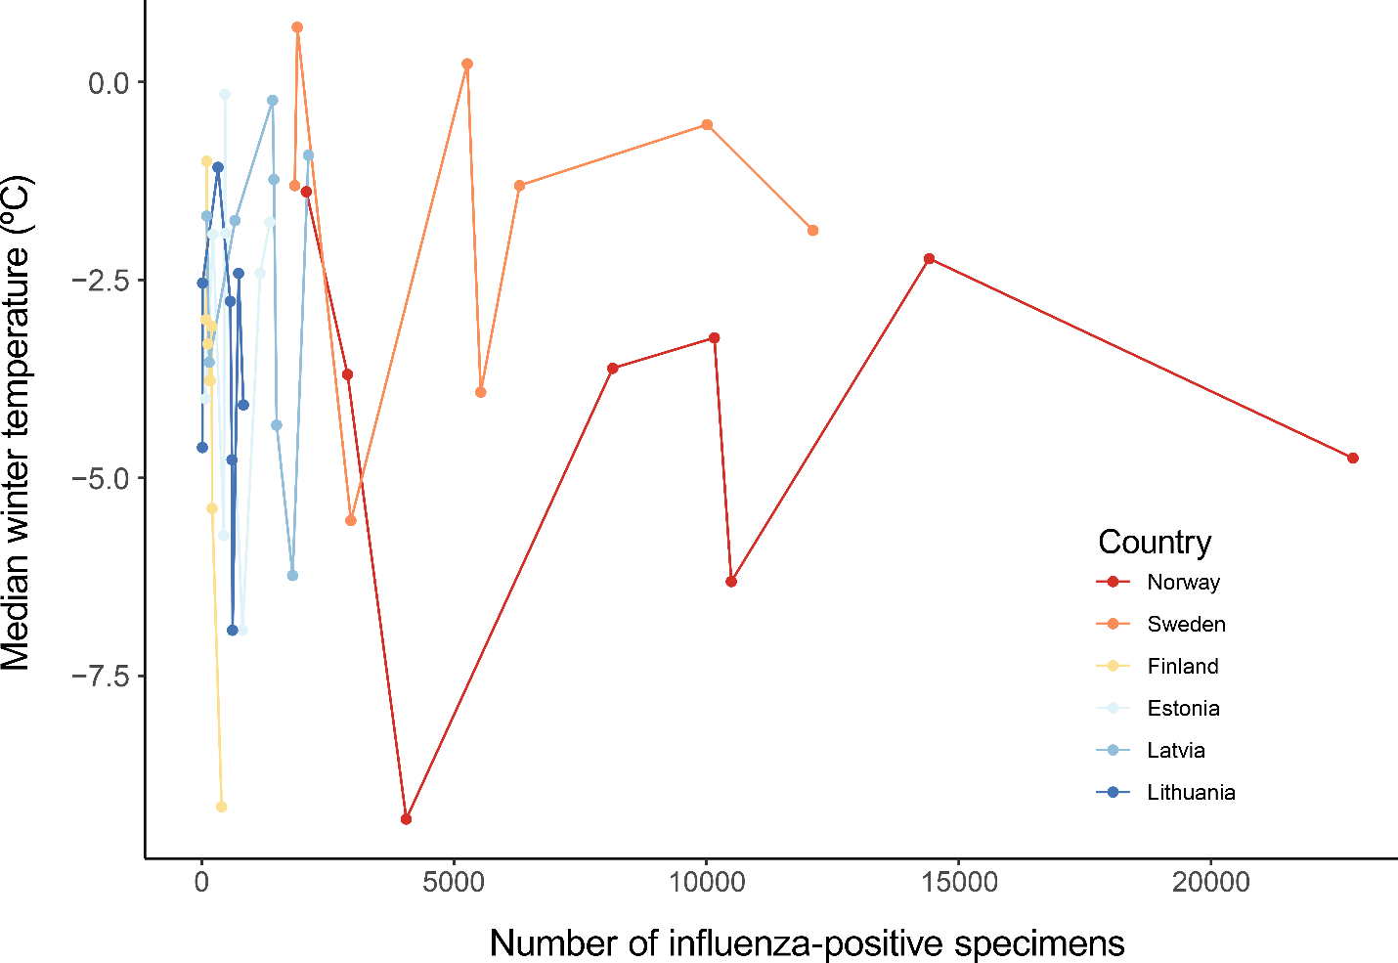
Figure S3: Graph showing relation between the number of influenza-positive specimens and the median winter temperatures (2010-2018) in six Northern European countries. Cox-Stuart statistical test was used to check whether the data has increasing/decreasing trends (p-values: Lithuania, 0.02; Estonia, 0.50; Finland, 0.02; Latvia, 0.16; Sweden, 0.69; Norway, 0.31).

