**Supporting Information**

**Hybrid delivery systems for methotrexate - lipidic liquid crystalline cubic phases and cubosomes with magnetic nanoparticles**

Monika Mierzwa, Paweł Krysiński, Renata Bilewicz *

Faculty of Chemistry, University of Warsaw, Pasteura 1, PL 02-093 Warsaw, Poland

S1

The SAXS measurement, allows to obtain one dimensional function of scattering intensities in function of q - I(q) where q (nm-1) is the length of the scattering vector.

The scattering vector is related to the scattering angle – θ – and the wavelength of radiation – λ (in our case it is λCu,Kα = 0.1542 nm) by the relation [1]:

$q=\frac{4πsinθ}{λ}$ [1s]

The qi peak values are marked starting with q0 and the ratio qi/q0 is calculated. The ratio defines the phase symmetry and Miller indices of the Bragg peak. The lattice parameter *a* (nm-1) is calculated from the distance between 2 reflection plans *d*.

For cubic phases:

$a=d_{hkl}\sqrt{h^{2}{+k}^{2}+l^{2}}$ [2s]

$d_{hkl}=\frac{2π}{q}$ [3s]

$a=\frac{2π}{q}\sqrt{h^{2}{+k}^{2}+l^{2}}$ [4s]

Size of the water channels was calculated using the lattice parameter and the composition of cubic phases:

φw = [5s]

where φw - water volume fraction, Cw - water weight fraction, ρw - density of water = 0.997 g/cm3, ρl - density of lipid, in our case ρMO = 0.942 g/cm3.

Lipid volume fraction was determined from the equation:

φl = 1- φw [6s]

Lipid chain length (*l*) was determined by solving the following equation [2]:

$φlipid=2δ\left(\frac{l}{a}\right)+\frac{4}{3}πχ{\left(\frac{l}{a}\right)}^{3}$ [7s]

δ - ratio of the minimal surface in a unit cell to the quantity (unit cell volume)2/3,χ - Euler–Poincare´ characteristic, *a* - lattice parameter of corresponding phase, *l* - lipid chain length/monolayer thickness.

Radius of water channels - *rw* was obtained by equation [3]:

$r_{w}={\left(\frac{-δ}{2πχ}\right)}^{1/2}a-l$ [8s]

1. Kulkarni, Ch. V.; Wachter, W.; Iglesias-Salto, G.; Engelskirchenb, S.; Ahualliac, S.Monoolein: a magic lipid? Physical Chemistry Chemical Physics **2011**, 13, 3004–3021, doi:10.1039/c0cp01539c2.
2. Turner, D. C.; Wang, Z.-G.; Gruner, S. M.; Mannock, D. A.; McElhaney, R. N. Structural Study of the Inverted Cubic Phases of di- Dodecyl Alkyl-β-D-Glucopyranosyl-rac-Glycerol. Journal de Physique II **1992**, 2, 2039−2063, doi:10.1051/jp2:1992250.
3. 3. Anderson, D. M.; Gruner, S. M.; Leibler, S. Geometrical Aspects of the Frustration in the Cubic Phases of Lyotropic Liquid Crystals. Proceedings of the National Academy of Sciences of the United States of America **1988**, 85, 5364−5368, www.jstor.org/stable/32152.

S2 Scheme of the reduction process of methotrexate [1].



1. Pontinha, A. D. R.; Jorge, S. M. A.; Diculescu, V. C.; Vivan, M.; Oliveira-Brett, A. M. Antineoplasic Drug Methotrexate Redox Mechanism Using a Glassy Carbon Electrode. Electroanalysis **2012**, 24, 917–923, doi:10.1002/elan.201100558.

S3 Release profiles of MTX from a cubic phase in pH 7.4 at 25[A] and 37ºC [B].

C:\Users\MonikaSzl\Desktop\Methotrexate\do atykułu MTX\ik w roznych temperaturach.tif

S4 DPV on GC electrode modified with phases without [A] and with [B] magnetic nanoparticles and the release profiles of MTX from LCPs [C] at pH 7.4 at 25ºC.

C:\Users\MonikaSzl\Desktop\s 4 kropki.tif

S5 The size [A] and zeta potential [B] of magnetocubosomes containing MTX determined with DLS at 25ºC.

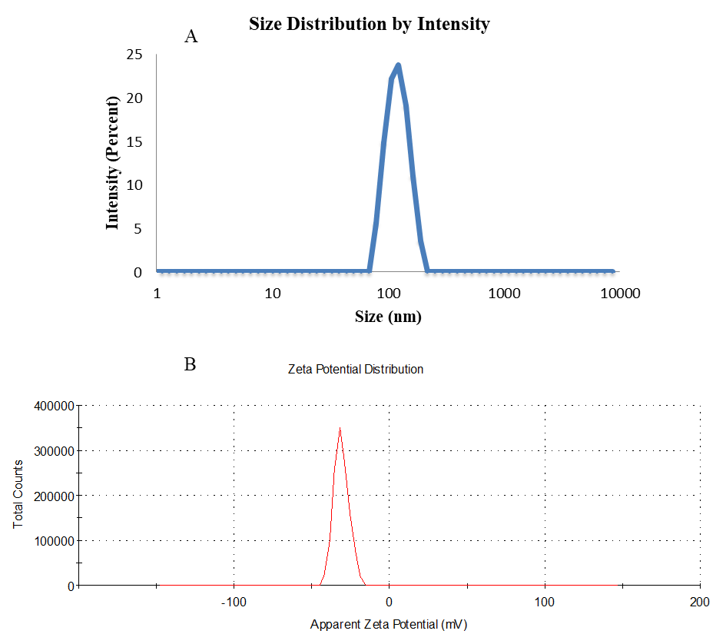

S6 Standard calibration curve for methotrexate based on measurement at 303 nm in 0.1 M phosphate buffer, pH 7.4.

C:\Users\MonikaSzl\Desktop\s 6 kropki.tif

S7 Electron cryo-microscopy images of cubosomes [A] and magnetocubosome [B].

C:\Users\MonikaSzl\Desktop\Methotrexate\do atykułu MTX\rysunki\cubosomes sup inf.tif