Supplementary Materials

Shape-memory Nanofiber Meshes with Programmable Cell Orientation
Eri Niiyama^{1,2}, Kanta Tanabe^{1,3}, Koichiro Uto⁴, Akihiko Kikuchi³ and Mitsuhiro Ebara^{1,2,3*}
¹ International Center for Materials Nanoarchitectonics (WPI-MANA), National Institute for Materials Science (NIMS), Tsukuba, Ibaraki 305-0044, Japan
² Graduate School of Pure and Applied Sciences, University of Tsukuba, Tsukuba, Ibaraki 305-8577, Japan
³ Department of Materials Science and Technology, Tokyo University of Science, 6-3-1 Niijuku, Katsushika, Tokyo 125-8585, Japan
⁴ International Center for Young Scientists (ICYS), National Institute for Materials Science (NIMS), Tsukuba, Ibaraki 305-0044, Japan
* Correspondence: EBARA.Mitsuhiro@nims.go.jp

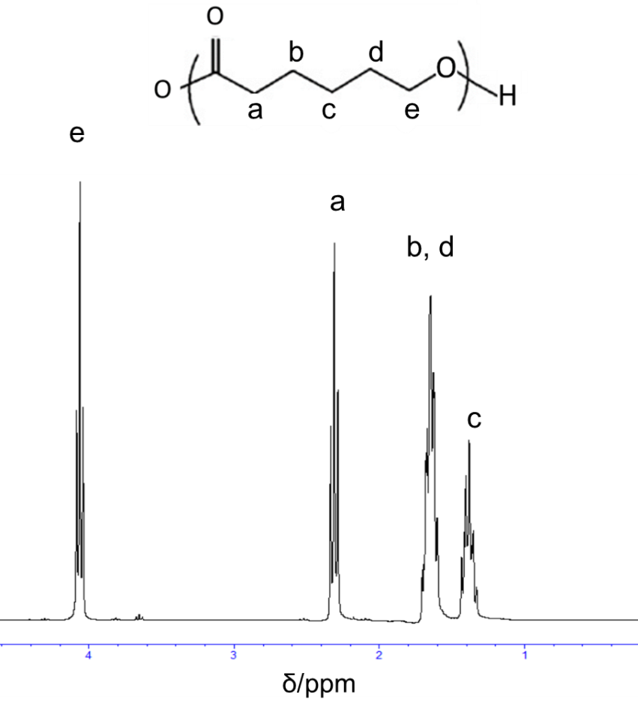
Figure S1. ¹H-NMR spectrum of PCL.

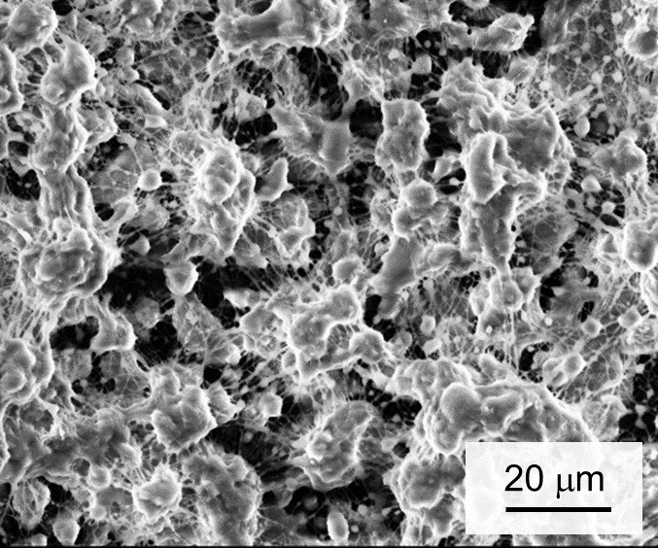
Figure S2. SEM image of electrospun PCL with molecular weight of 5,000.

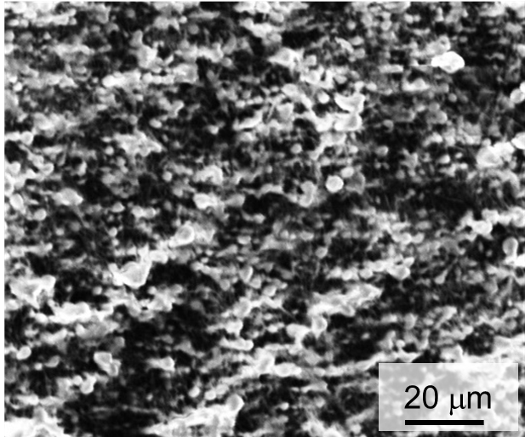
Figure S3. SEM image of electrospun fibers from PCL-21.3 (400× magnification).

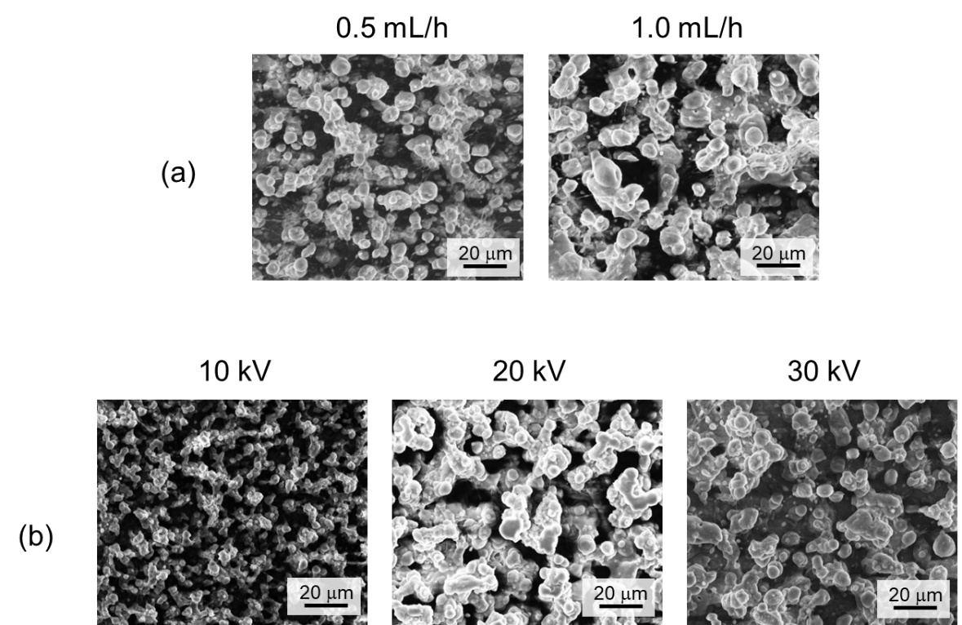
Figure S4. SEM images of electrospun fibers from four-branched PCL with different flow rates (0.5 mL and 1.0 mL) and voltages (10, 20, and 30 kV).

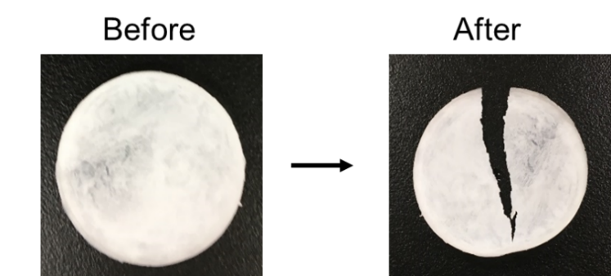
Figure S5. PCL-21.3 film before and after heating at 80°C.

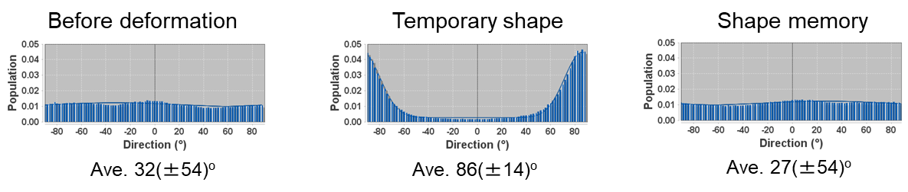
Figure S6. Orientation analysis of PCL-9.2 nanofibers from SEM images shown in Figure 4(a) before deformation, after deformation, and after shape memory recovery.

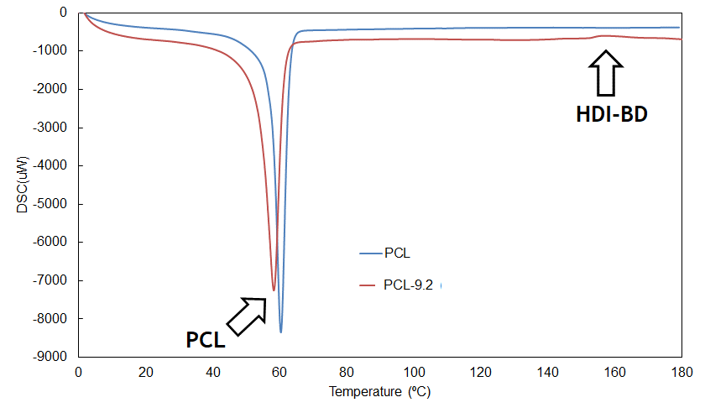
Figure S7. DSC curve of electrospun nanofiber of pure PCL and PCL-9.2.

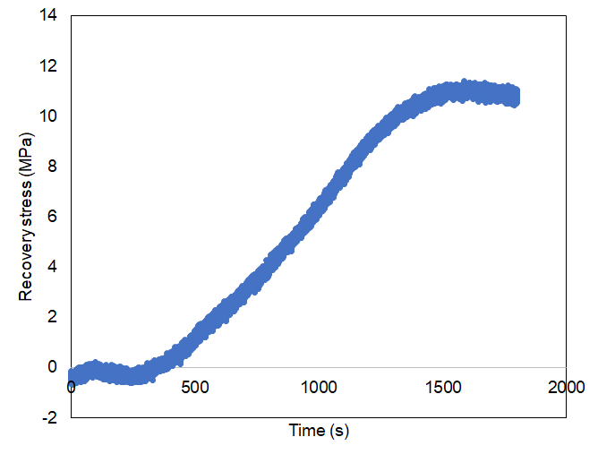
Figure S8. Recovery stress of electrospun PCL-9.2 nanofiber mesh.

