Supporting information

Species and bio-availability of inorganic and organic phosphorus in primary, secondary and digested sludge
Shaoxiong Zhang ¹, Wenli Huang ^{2,3,}* and Dongfang Liu ²
¹ School of Civil Engineering, Shijiazhuang Tiedao University, Shijiazhuang 050043, China; zhangsx@stdu.edu.cn (S. Z);
² Key Laboratory of Pollution Process and Environmental Criteria, Ministry of Education, College of Environmental Science and Engineering, Nankai University, 38 Tongyan Road, Haihe Education Park, Tianjin 300350, China; huangwenli@nankai.edu.cn (W. H); 3578145273@qq.com (D.L)
³ Graduate School of Life and Environmental Sciences, University of Tsukuba, 1-1-1 Tennodai, Tsukuba, Ibaraki 305-8572, Japan
* Correspondence: huangwenli@nankai.edu.cn; Tel.: +86 22-23501117

Table S1. Variation of COD, NH₄-N, TP, and PO₄-P in the influent and effluent from the treatment units of the WWTP
Treatment units | COD  (mg/l) | NH₄-N  (mg/l) | TP  (mg/l) | PO₄-P  (mg/l)
Influent | 205.3 | 28.3 | 3.0 | 2.3
Primary settling tank effluent | 248.8 | 30.2 | 3.5 | 3.4
Digestion tank effluent | 714.2 | 636.9 | 241.4 | 211.8
Effluent | 19.3 | 1.3 | 0.2 | 0.1
COD, chemical oxygen demand; TP, total phosporus.
(9)
(5)
(4)
(3)
(2)
(1)
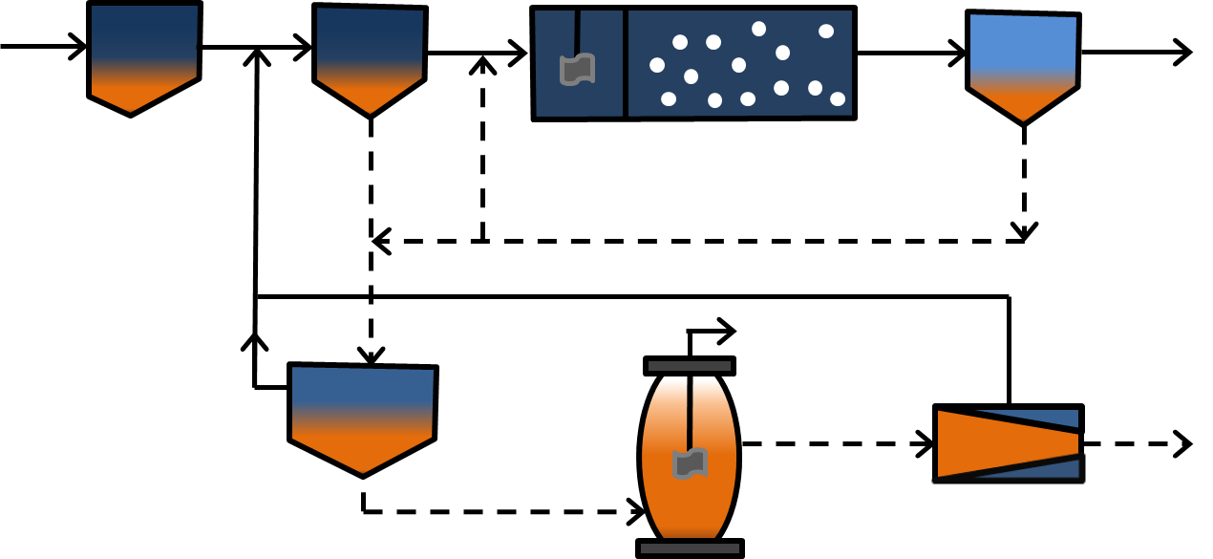
Biogas
Sludge
Water
(6)
(7)
(8)
(10)
Figure S1. Process flow diagram of wastewater treatment plant in Shimodate, Ibaraki Prefecture, Japan. (1) influent, (2) grid, (3) primary settling tank, (4) aeration tank, (5) secondary settling tank, (6) sludge concentration tank, (7) digestion tank, (8) sludge dewatering, (9) effluent, (10) sludge disposal.

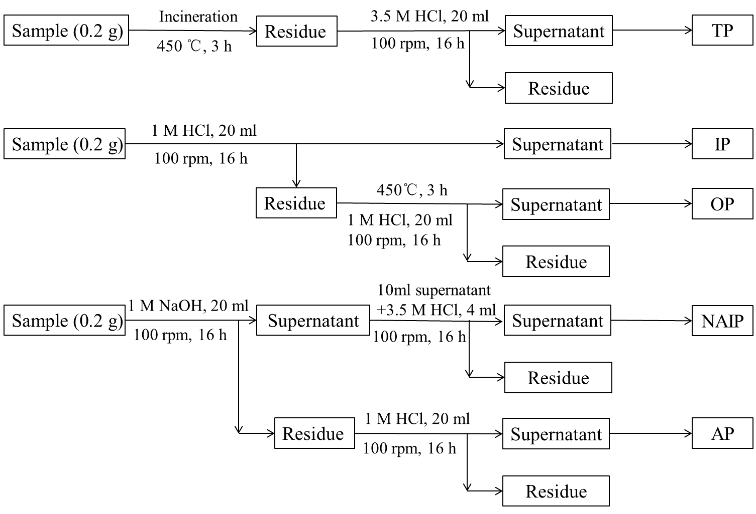
Fig. S2. The schematic diagram of the SMT protocol (Ruban, 1999; Medeiros, 2005).

