SUPPLEMENTARY MATERIAL

Macroeconomic impacts of climate change associated with changes in crop yields

- Supplementary figures
Figure S1 Asia-Pacific Integrated Model (AIM) modeling framework

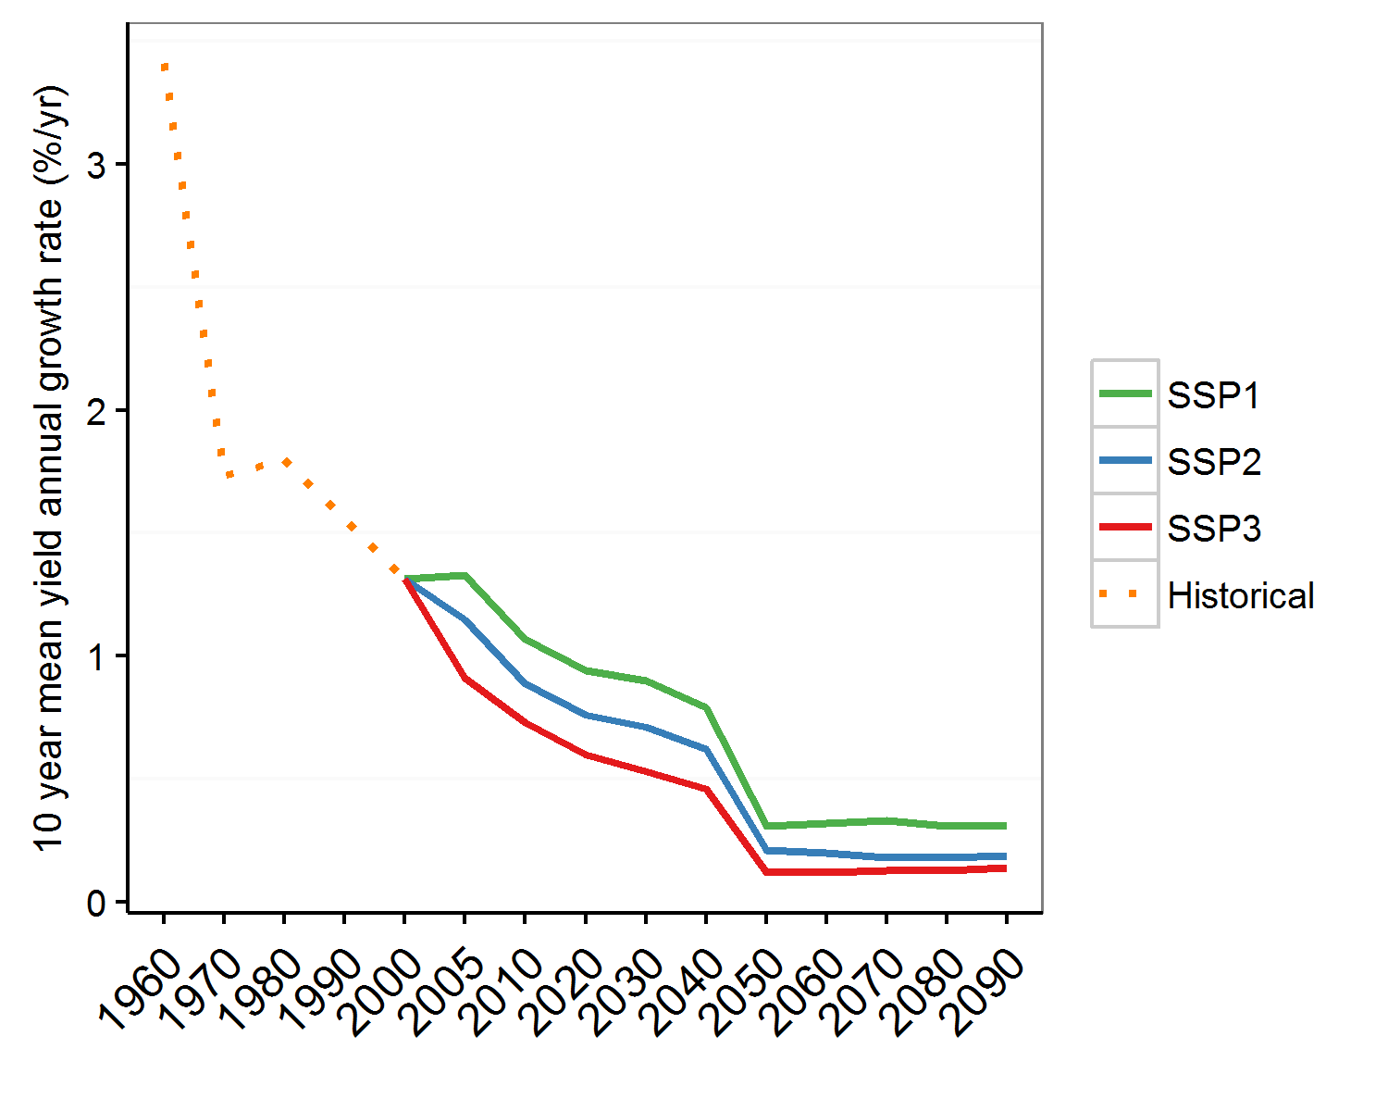
Figure S2 Ten-year mean annual yield growth rate for the SSP1, SSP2, and SSP3 baseline
367 scenarios. The x-axis represents each decadal period (i.e., 1960 means the 1960s). This figure is adopted from Fujimori et al. (2017)

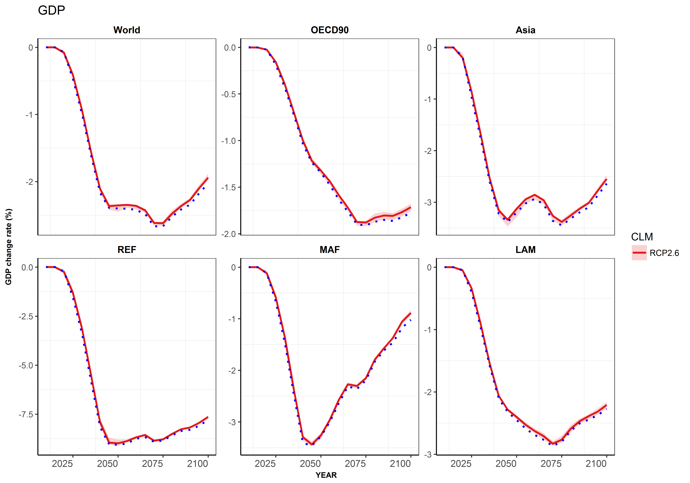
Figure S3 The macroeconomic impact due to mitigation policy (RCP2.6 equivalent) and agricultural yield change for RCP2.6 for five regions and the global total. All cases considered a mitigation policy, but the dotted line indicates no consideration of climate change (NoCC), while the red colored ribbon indicates the cases where the impact of climate change was considered. The red line is the median of the climate change impact cases. Regional codes are OECD90, OECD regions; Asia, Asia; REF, Reforming region; MAF, Middle East and Africa; and LAM, Latin America (The mapping procedure from 17 regions is shown in Table S1).

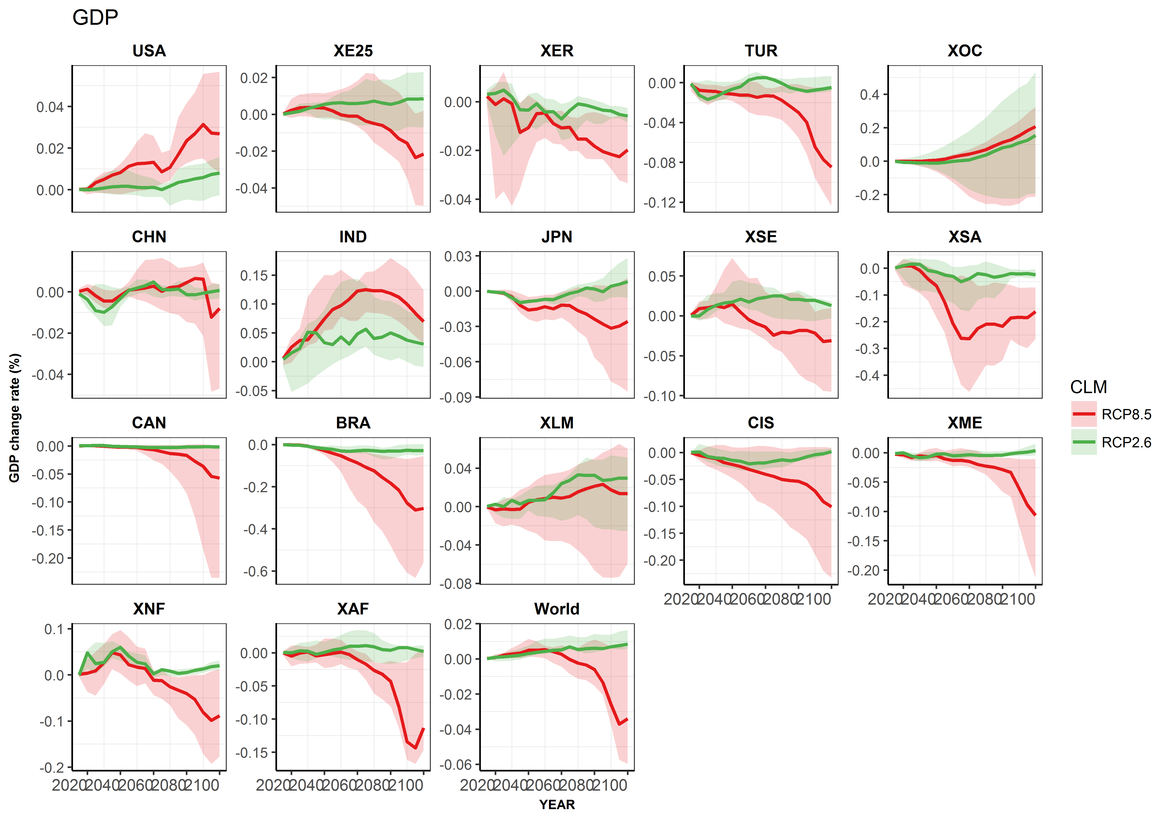
Figure S 4 Macroeconomic impact due to changes in agricultural yield in SSP2 in five regions and as a global total. The colors represent climate change level (RCPs). The shaded area is the general circulation model (GCM) range of uncertainty (five GCMs for RCP8.5, and RCP2.6). The lines are the median of five GCMs for each RCP2.6 and RC`8.5. The scenarios in which CO₂ fertilization and land-use change are both included are shown. Regional codes are shown in Table S1).

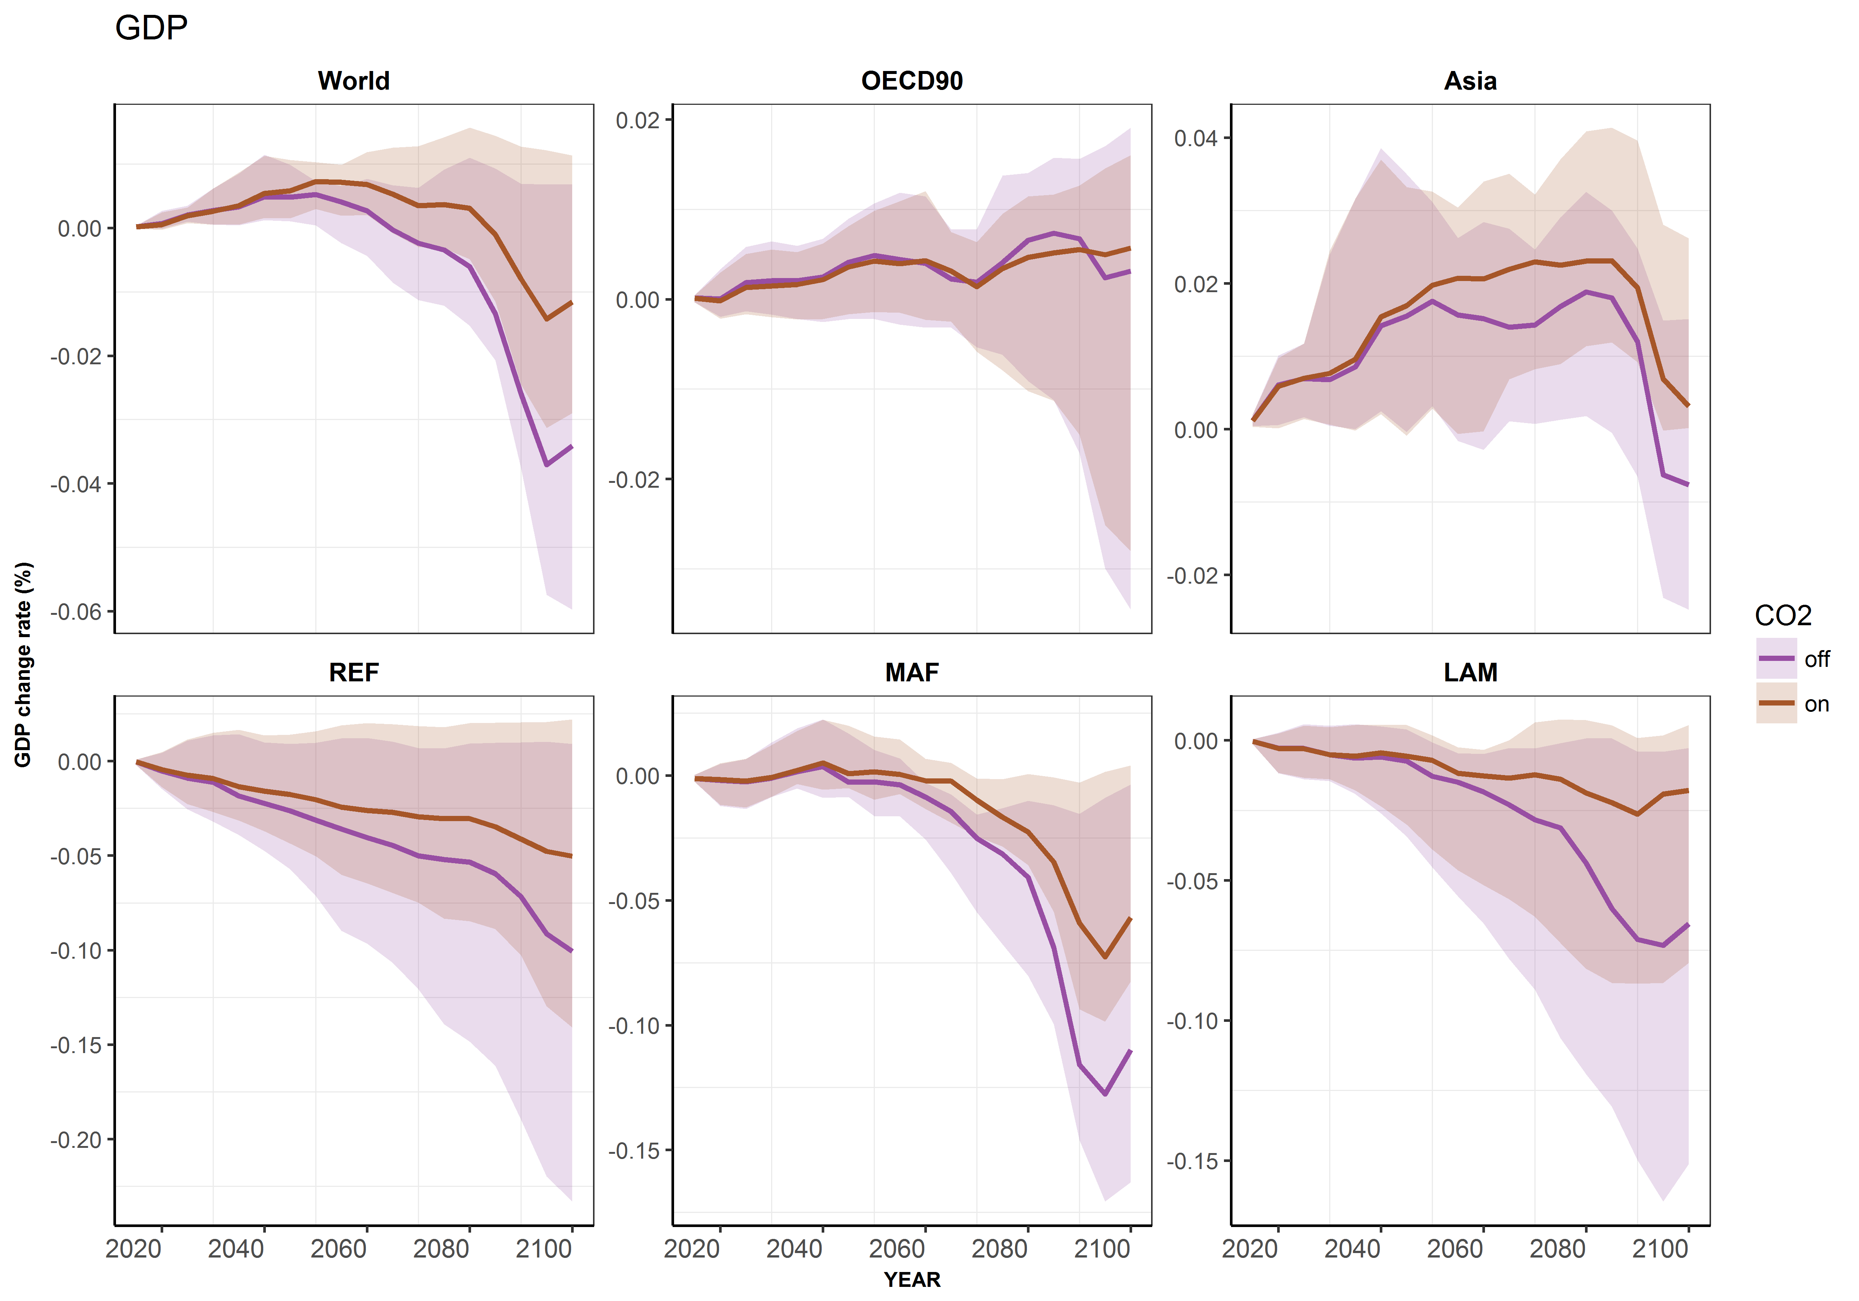
Figure S5 The macroeconomic impact due to changes in agricultural yield for RCP8.5 with and without CO₂ fertilization for five regions and the global total. The red and purple colored ribbons indicate the cases with and without consideration of CO₂ fertilization. The line is the median for each case. Regional codes are OECD90, OECD regions; Asia, Asia; REF, Reforming region; MAF, Middle East and Africa; and LAM, Latin America (The mapping procedure from 17 regions is shown in Table S1).

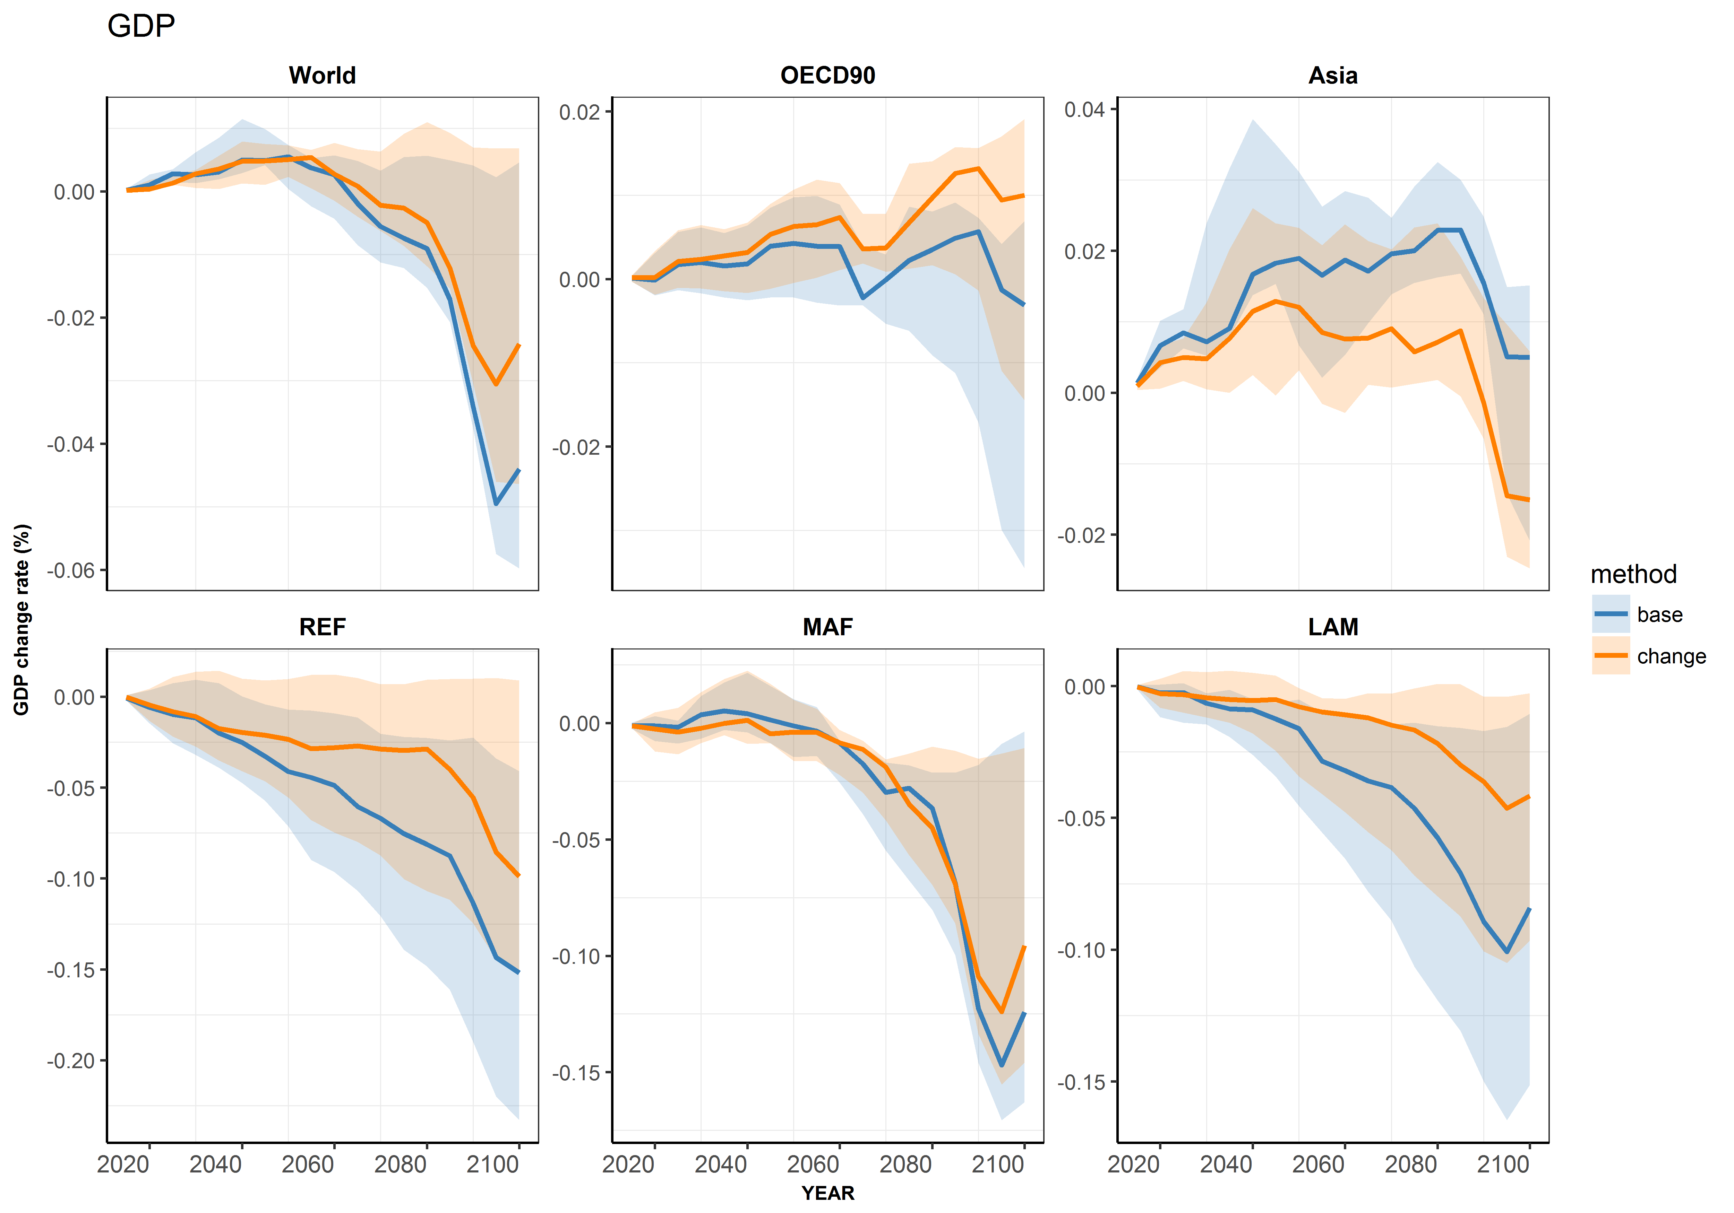
Figure S6 The macroeconomic impact due to changes in the agricultural yield for RCP8.5 with and without consideration of land-use change for five regions and the global total. The orange and blue colored ribbons indicate the cases with and without land-use change (change, with land-use; base, without land-use). The line is the median for each case. Regional codes are OECD90, OECD regions; Asia, Asia; REF, Reforming region; MAF, Middle East and Africa; and LAM, Latin America (The mapping procedure from 17 regions is shown in Table S1).

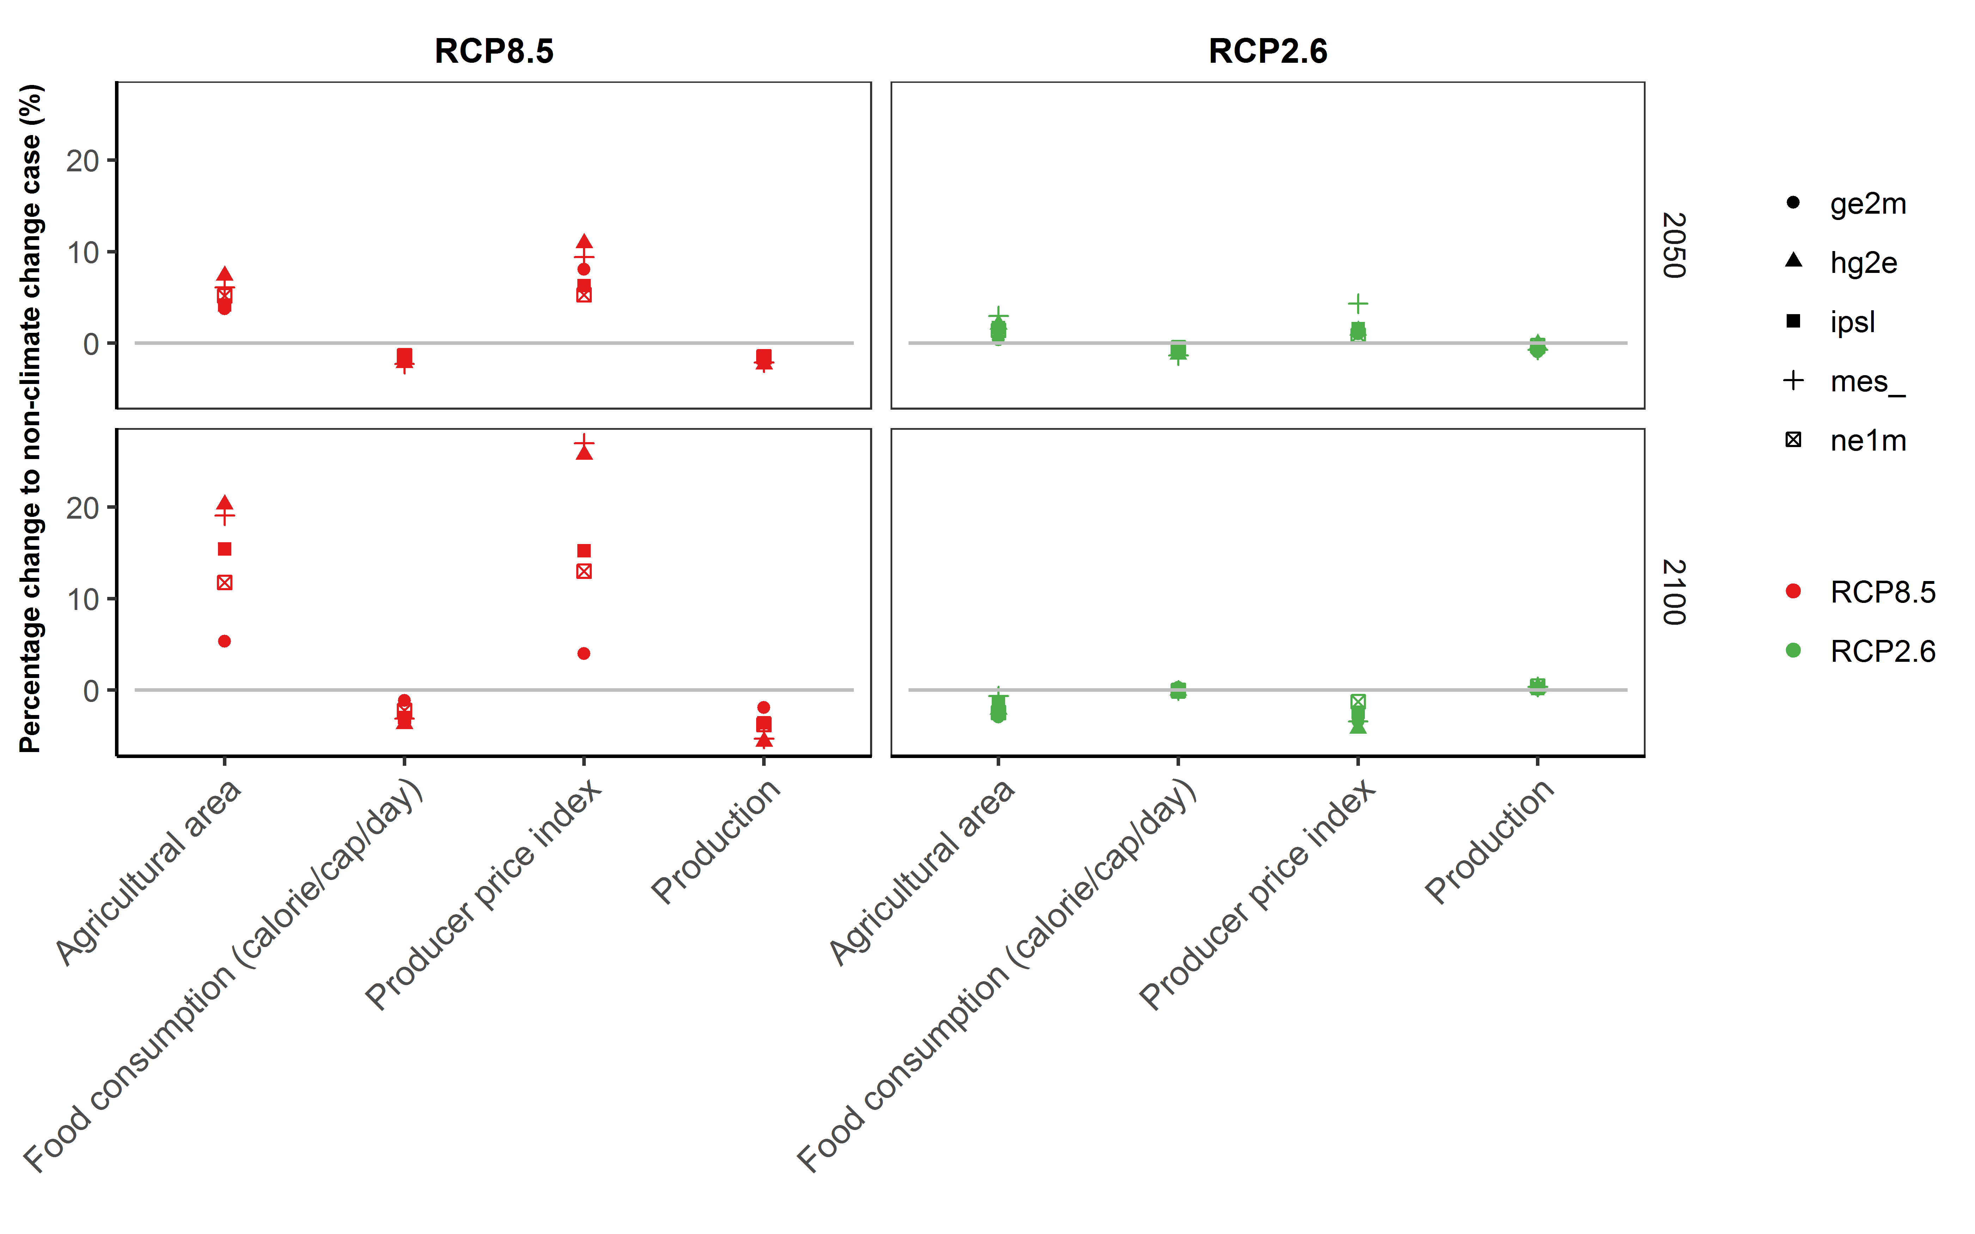
Figure S7 Global main indicators’ changes for RCP2.6 (right) and RCP8.5 (left) in 2050 (top) and 2010 (bottom). The main indicators the main indicators here are agricultural area, food consumption, producer price, and production. The values are all presented as percentage changes compared to baseline no climate change cases.

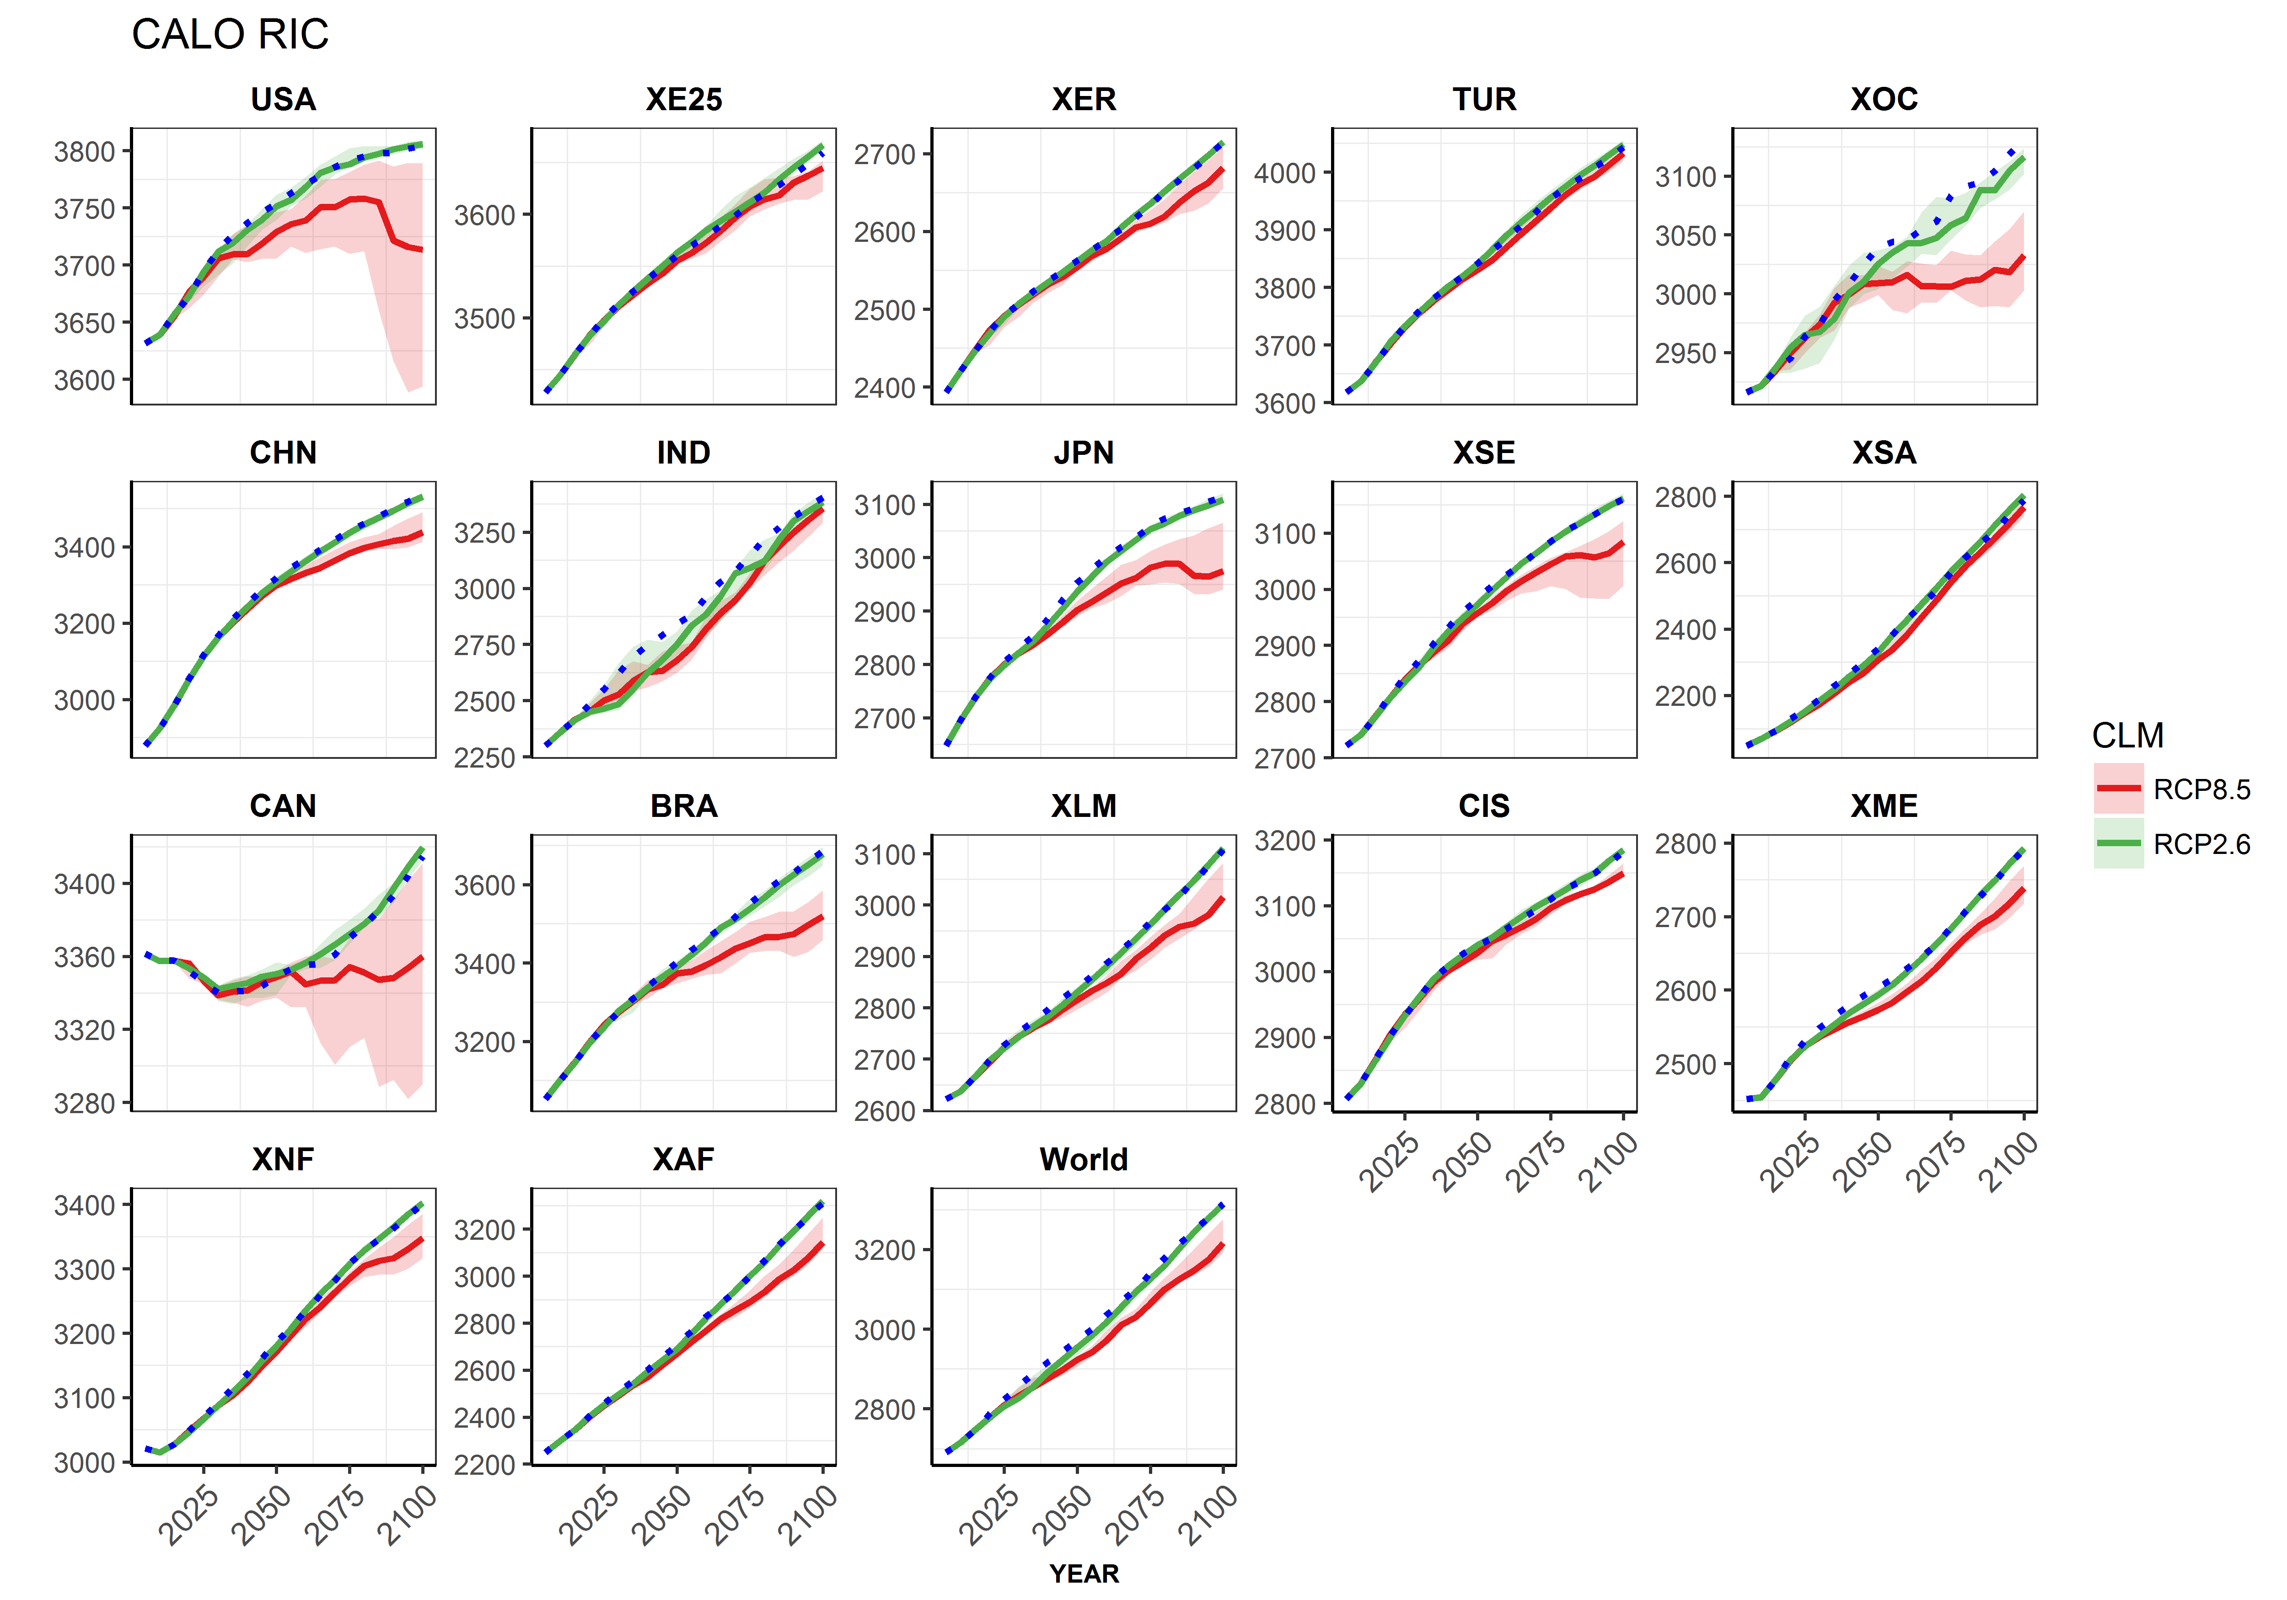
Figure S8 Food consumption as colorific in take per capita, per day change for the 17 regions of the Asia-Pacific Integrated Model / Computable General Equilibrium (AIM/CGE) and the global average in two climate-change cases (green; RCP2.6 and red; RCP8.5) and the no climate-change (NoCC) case (blue dot). The ribbon indicates the range of uncertainty of five general circulation models (GCMs). The unit is t/ha.

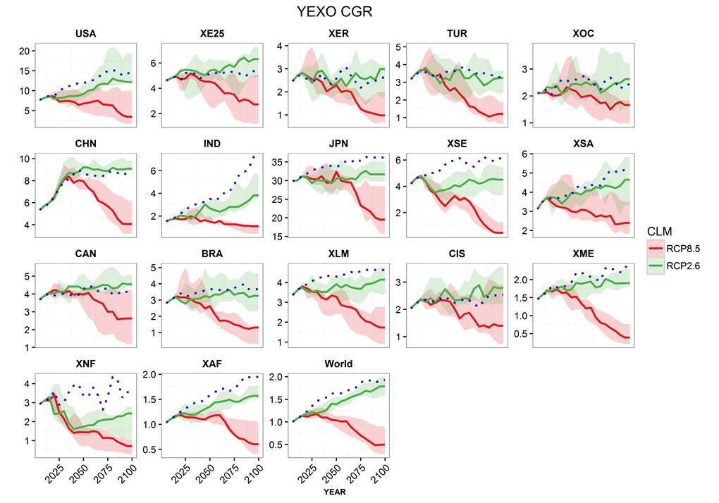
Figure S9 Yield change of coarse grains for the 17 regions of the Asia-Pacific Integrated Model / Computable General Equilibrium (AIM/CGE) and the global average in two climate-change cases (green; RCP2.6 and red; RCP8.5) and the no climate-change (NoCC) case (blue dot). The ribbon indicates the range of uncertainty of five general circulation models (GCMs). The unit is t/ha.

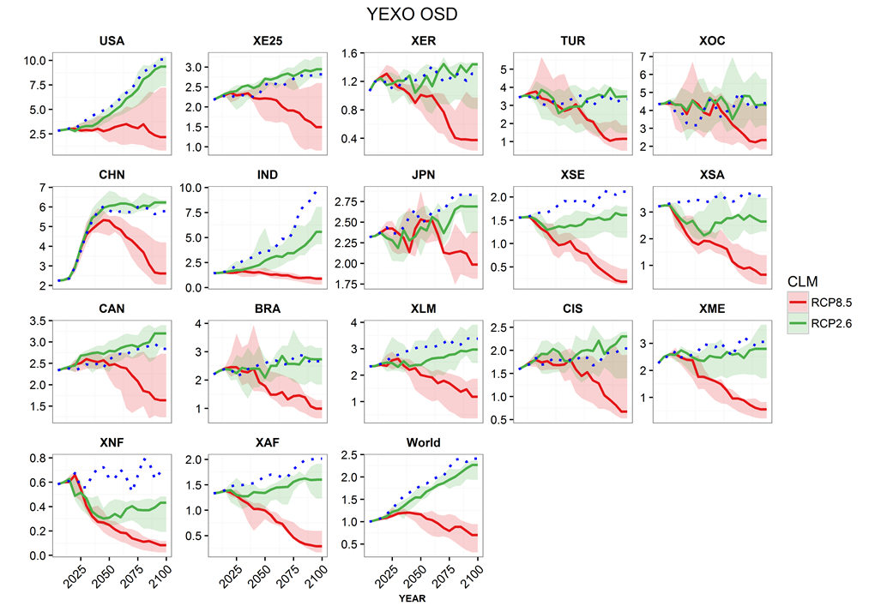
Figure S10 Yield change of oil seeds for the 17 regions of the Asia-Pacific Integrated Model / Computable General Equilibrium (AIM/CGE) and the global average in two climate-change cases (green; RCP2.6 and red; RCP8.5) and the no climate-change (NoCC) case (blue dot). The ribbon indicates the range of uncertainty of five general circulation models (GCMs). The unit is t/ha.

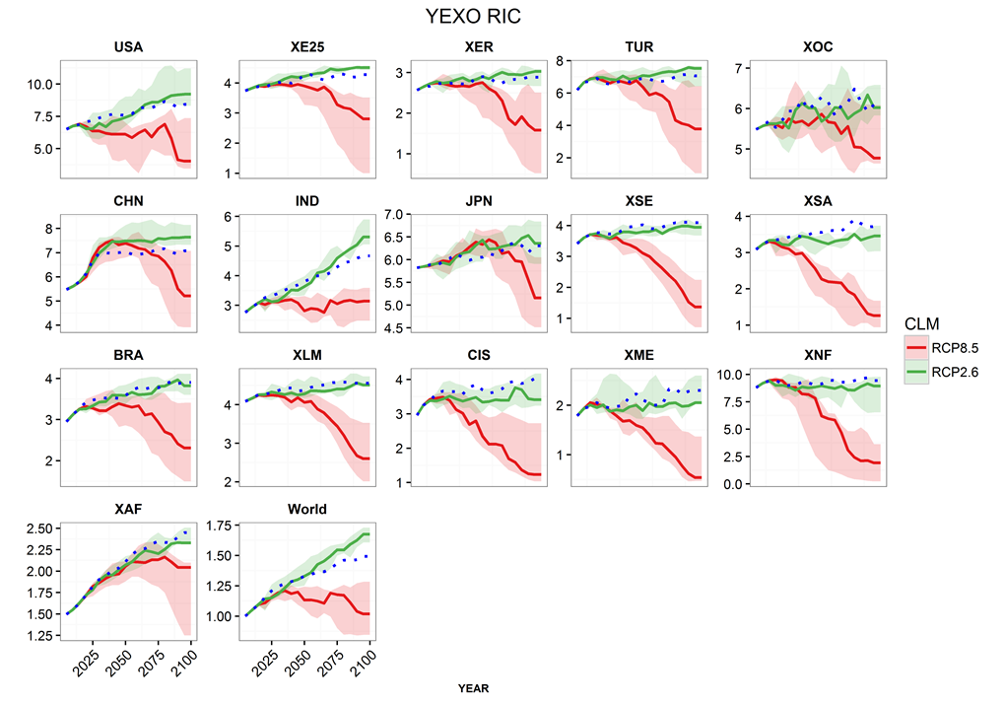
Figure S11 Yield change of rice for the 17 regions of the Asia-Pacific Integrated Model / Computable General Equilibrium (AIM/CGE) and the global average in two climate-change cases (green; RCP2.6 and red; RCP8.5) and the no climate-change (NoCC) case (blue dot). The ribbon indicates the range of uncertainty of five general circulation models (GCMs). The unit is t/ha.

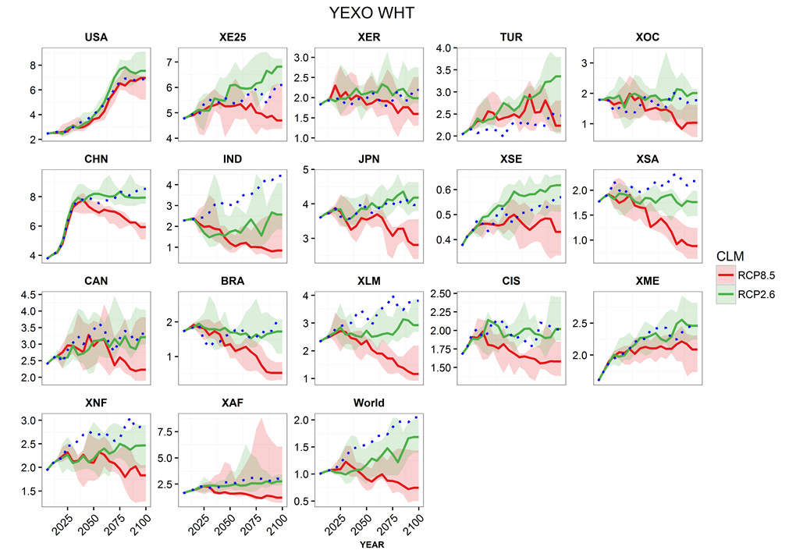
Figure S12 Yield change of wheat for the 17 regions of the Asia-Pacific Integrated Model / Computable General Equilibrium (AIM/CGE) and the global average in two climate-change cases (green; RCP2.6 and red; RCP8.5) and the no climate-change (NoCC) case (blue dot). The ribbon indicates the range of uncertainty of five general circulation models (GCMs). The unit is t/ha.

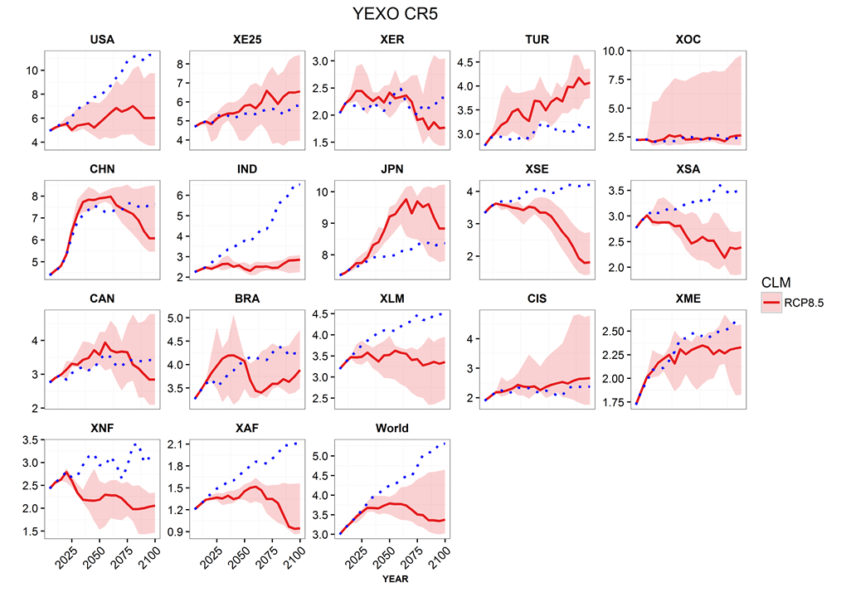
Figure S13 Yield change of five major crops for the 17 regions of the Asia-Pacific Integrated Model / Computable General Equilibrium (AIM/CGE) and the global average in a climate-change (RCP8.5) case and the no climate-change (NoCC) cases (blue dot). The ribbon indicates the range of uncertainty of five general circulation models (GCMs). The unit is t/ha. Here, CO₂ fertilization is considered.

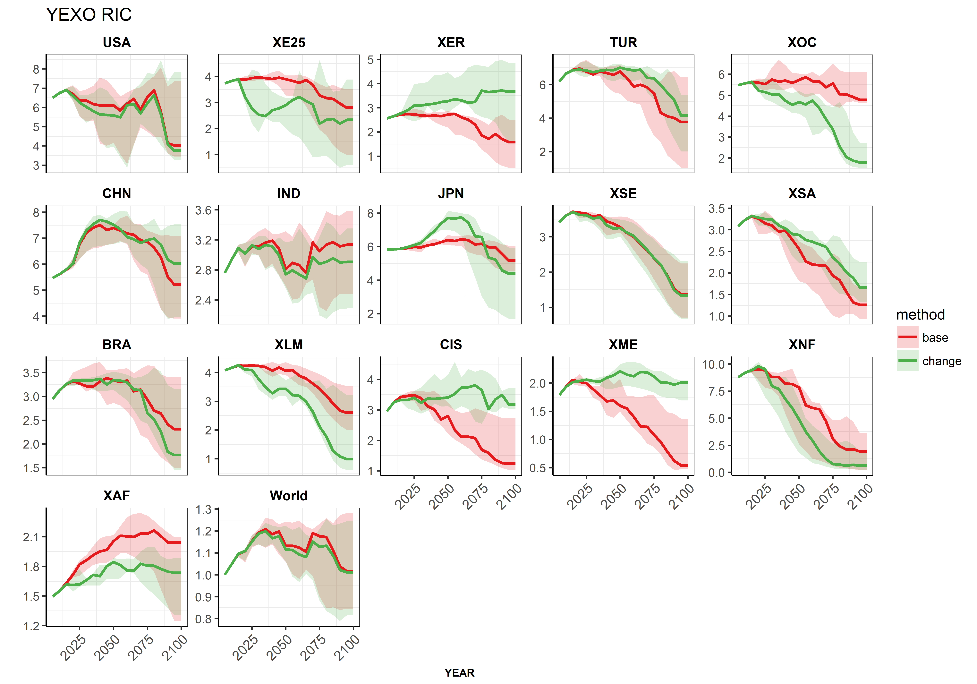
Figure S14 Rice yield for 17 regions in the Asia-Pacific Integrated Model / Computable General Equilibrium (AIM/CGE) and the global average in two gridded yield aggregation method associated with land-use change (red; fixed as base year harvested area and red; changed dynamically) under RCP8.5 and non-CO₂ fertilization cases. The ribbon indicates the range of uncertainty for five general circulation models (GCMs). The units are t/Ha.

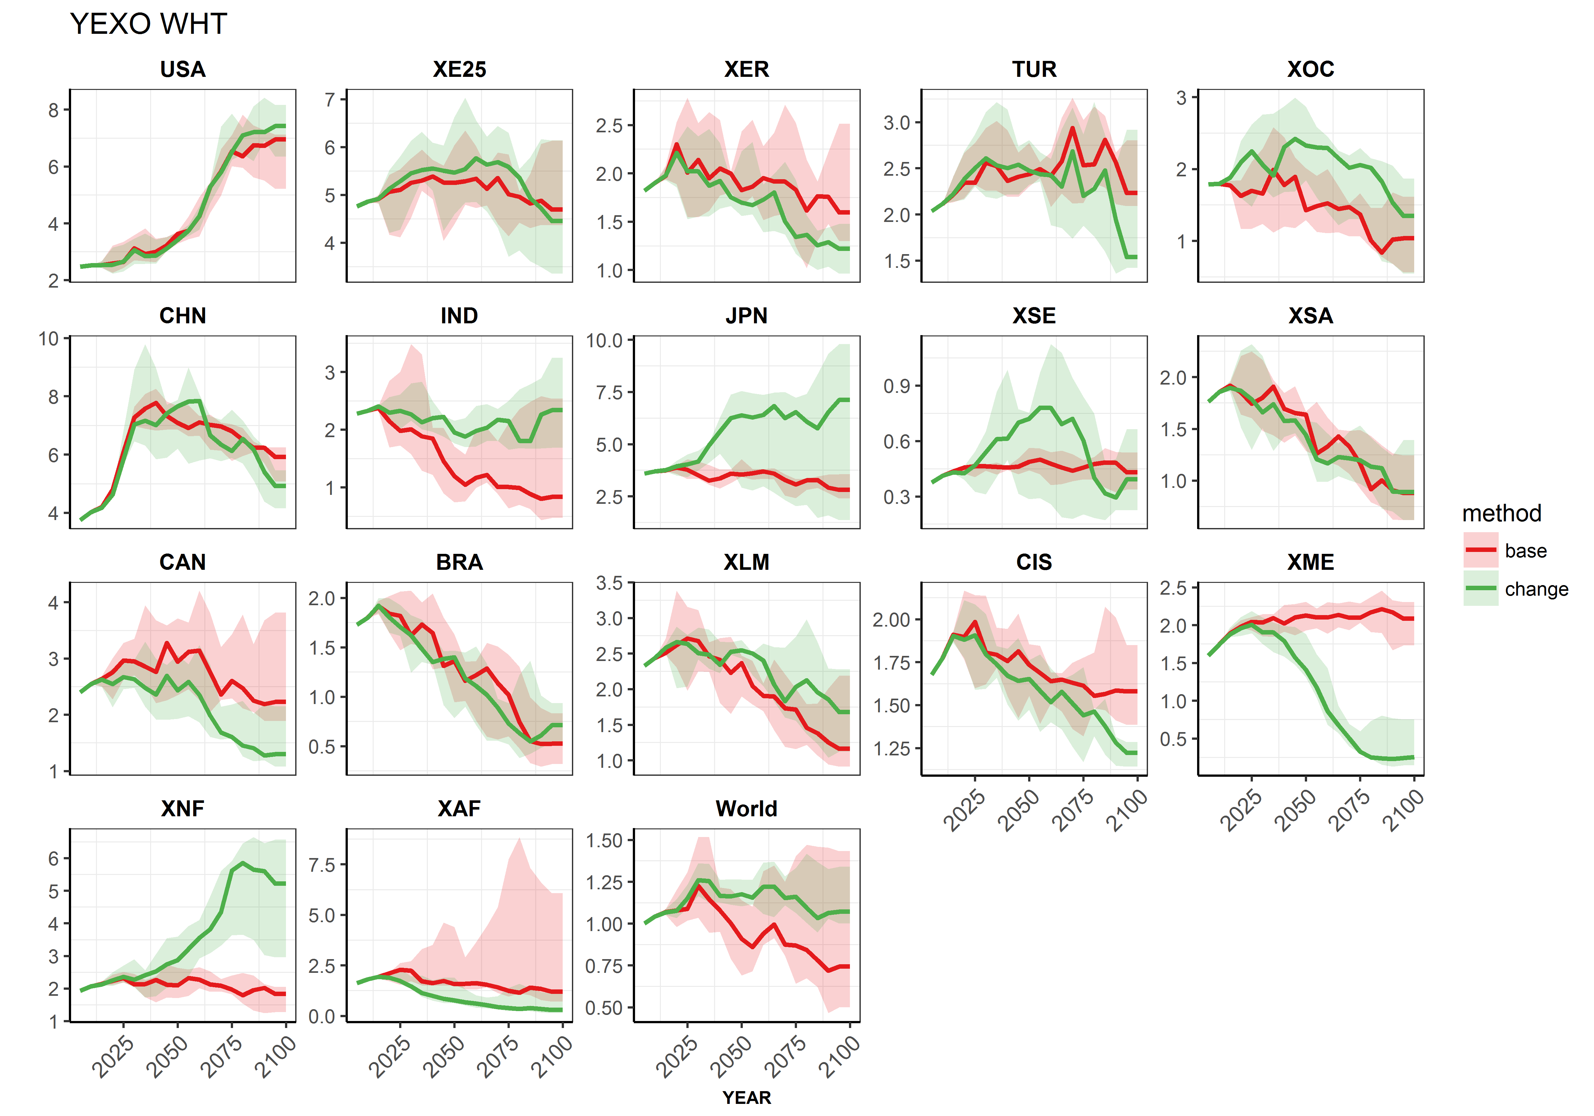
Figure S15 wheat yield for 17 regions in the Asia-Pacific Integrated Model / Computable General Equilibrium (AIM/CGE) and the global average in two gridded yield aggregation method associated with land-use change (red; fixed as base year harvested area and red; changed dynamically) under RCP8.5 and non-CO₂ fertilization cases. The ribbon indicates the range of uncertainty for five general circulation models (GCMs). The units are t/Ha.

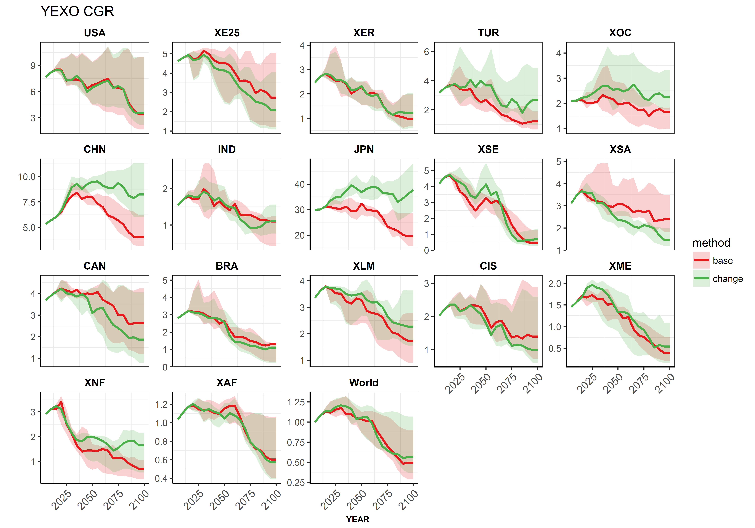
Figure S16 Coarse grain yield for 17 regions in the Asia-Pacific Integrated Model / Computable General Equilibrium (AIM/CGE) and the global average in two gridded yield aggregation method associated with land-use change (red; fixed as base year harvested area and red; changed dynamically) under RCP8.5 and non-CO₂ fertilization cases. The ribbon indicates the range of uncertainty for five general circulation models (GCMs). The units are t/Ha.

- Supplementary tables
Table S1 Region classification
Code | Region | Code | Region
JPN | Japan | TUR | Turkey
CHN | China | CAN | Canada
IND | India | USA | United States
XSE | Southeast Asia | BRA | Brazil
XSA | Rest of Asia | XLM | Rest of South America
XOC | Oceania | XME | Middle East
XE25 | EU25 | XNF | North Africa
XER | Rest of Europe | XAF | Rest of Africa
CIS | Former Soviet Union

Table S2 Land use classification
Cropland | Wheat irrigated
Cropland | Other coarse grains irrigated
Cropland | Oil crops irrigated
Cropland | Sugar crops irrigated
Cropland | Rice rainfed
Cropland | Wheat rainfed
Cropland | Other coarse grains rainfed
Cropland | Oil crops rainfed
Cropland | Sugar crops rainfed
Cropland | Other crops
Cropland | Bioenergy crops
Afforestation
Settlement
Ice and water
Other land use
Forest
Pasture
Other natural vegetation

Table S3 Industrial classification
Agricultural sector | Energy supply sector | Other production sector
Rice | Coal mining | Mineral mining and other quarrying
Wheat | Oil mining | Food products
Other grains | Gas mining | Textiles, apparel, and leather
Oil seed crops | Petroleum refinery | Wood products
Sugar crops | Coal transformation | Paper, paper products, and pulp
Other crops | Biomass transformation (1st generation) | Chemical, plastic, and rubber products
Ruminant livestock | Biomass transformation (2nd generation with energy crop) | Iron and steel
Raw milk | Biomass transformation (2nd generation with residue) | Nonferrous products
Other livestock and fisheries | Gas manufactures distribution | Other manufacturing
Forestry | Coal-fired power | Construction
 | Oil-fired power | Transport and communications
 | Gas-fired power | Other service sectors
 | Nuclear power | CCS service
 | Hydroelectric power
 | Geothermal power
 | Photovoltaic power
 | Wind power
 | Waste biomass power
 | Other renewable energy power generation
 | Advanced biomass-power generation

Table S4 List of general circulation models (GCM)
Code | Model name
ge2m | GFDL-ESM2M
hg2e | HadGEM2-ES
ipsl | IPSL-CM5A-LR
mes_ | MIROC-ESM
ne1m | NorESM1-M

Table S5 Share of primary sector’s value added in total GDP for SSP1, SSP2 and SSP3
 |  | SSP1 |  | SSP2 |  | SSP3
 | 2005 | 2050 | 2100 | 2050 | 2100 | 2050 | 2100
United States | 1.2% | 0.6% | 0.6% | 0.7% | 0.6% | 0.7% | 0.8%
EU25 | 2.0% | 1.0% | 0.5% | 1.0% | 0.5% | 1.2% | 0.9%
Rest of Europe | 3.4% | 1.4% | 0.6% | 1.4% | 0.6% | 1.9% | 1.5%
Turkey | 11.0% | 4.9% | 2.2% | 4.9% | 2.2% | 6.9% | 6.7%
Oceania | 3.6% | 2.4% | 2.2% | 2.4% | 2.2% | 2.4% | 2.6%
China | 12.5% | 3.2% | 2.4% | 3.2% | 2.4% | 4.1% | 4.0%
India | 18.6% | 5.4% | 1.5% | 5.4% | 1.5% | 11.3% | 10.4%
Japan | 1.5% | 0.6% | 0.3% | 0.6% | 0.3% | 0.7% | 0.5%
Southeast Asia | 6.8% | 2.3% | 1.0% | 2.3% | 1.0% | 3.5% | 3.0%
Rest of Asia | 18.5% | 7.4% | 2.1% | 7.4% | 2.1% | 14.5% | 13.5%
Canada | 1.9% | 1.2% | 0.7% | 1.2% | 0.7% | 1.2% | 0.8%
Brazil | 6.1% | 2.2% | 1.1% | 2.2% | 1.1% | 3.2% | 3.5%
Rest of South America | 6.0% | 3.4% | 1.6% | 3.4% | 1.6% | 4.6% | 4.1%
Former Soviet Union | 6.6% | 2.4% | 1.3% | 2.4% | 1.3% | 3.0% | 2.5%
Middle East | 4.8% | 2.5% | 1.4% | 2.5% | 1.4% | 3.6% | 3.7%
North Africa | 11.4% | 4.2% | 1.7% | 4.2% | 1.7% | 6.6% | 5.9%
Rest of Africa | 16.2% | 6.8% | 2.6% | 6.8% | 2.6% | 11.7% | 11.8%
World | 3.7% | 2.3% | 1.3% | 2.3% | 1.3% | 3.2% | 3.9%

Table S6 Price elasticity in 2050 Baseline case. The numbers are derived from LES (Linear Expenditure System) consumption function
 | Wheat | Oil seed | Rice | Other grains | Other crops | Ruminant | Non-ruminant | Dairy product
USA | 0.00 | -0.05 | 0.00 | 0.00 | 0.00 | -0.04 | -0.04 | -0.04
XE25 | 0.00 | -0.05 | 0.00 | 0.00 | 0.00 | -0.04 | -0.04 | -0.04
XER | 0.00 | -0.13 | 0.00 | 0.00 | 0.00 | -0.06 | -0.06 | -0.06
TUR | -0.01 | -0.05 | -0.01 | -0.01 | -0.01 | -0.10 | -0.10 | -0.10
XOC | 0.00 | -0.05 | 0.00 | 0.00 | 0.00 | -0.05 | -0.05 | -0.05
CHN | 0.00 | -0.09 | 0.00 | 0.00 | 0.00 | -0.05 | -0.05 | -0.05
IND | -0.02 | -0.13 | -0.02 | -0.02 | -0.09 | NA | -0.13 | -0.13
JPN | 0.00 | -0.05 | 0.00 | 0.00 | 0.00 | -0.07 | -0.07 | -0.07
XSE | 0.00 | -0.05 | 0.00 | 0.00 | -0.04 | -0.10 | -0.11 | -0.10
XSA | -0.02 | -0.13 | -0.02 | -0.02 | -0.09 | -0.13 | -0.13 | -0.13
CAN | 0.00 | -0.05 | 0.00 | 0.00 | 0.00 | -0.04 | -0.04 | -0.04
BRA | -0.02 | -0.11 | -0.02 | -0.02 | 0.00 | -0.05 | -0.05 | -0.05
XLM | -0.02 | -0.11 | -0.02 | -0.02 | 0.00 | -0.07 | -0.07 | -0.07
CIS | 0.00 | -0.13 | 0.00 | 0.00 | 0.00 | -0.06 | -0.06 | -0.06
XME | -0.01 | -0.08 | -0.01 | -0.01 | -0.01 | -0.13 | -0.13 | -0.13
XNF | -0.01 | -0.08 | -0.01 | -0.01 | -0.01 | -0.12 | -0.12 | -0.12
XAF | -0.02 | -0.14 | -0.02 | -0.02 | -0.10 | -0.18 | -0.18 | -0.18

Table S7 Income elasticity in 2050 Baseline case. The numbers are derived from LES (Linear Expenditure System) consumption function
 | WHT | OSD | RIC | CGR | OCR | RUM | NRM | DRY
USA | 0.01 | 0.09 | 0.01 | 0.01 | 0.01 | 0.07 | 0.07 | 0.07
XE25 | 0.01 | 0.09 | 0.01 | 0.01 | 0.01 | 0.07 | 0.07 | 0.07
XER | 0.01 | 0.25 | 0.01 | 0.01 | 0.01 | 0.12 | 0.12 | 0.12
TUR | 0.01 | 0.10 | 0.01 | 0.01 | 0.01 | 0.19 | 0.19 | 0.19
XOC | 0.01 | 0.09 | 0.01 | 0.01 | 0.01 | 0.09 | 0.09 | 0.09
CHN | 0.01 | 0.17 | 0.01 | 0.01 | 0.01 | 0.10 | 0.10 | 0.10
IND | 0.03 | 0.25 | 0.03 | 0.03 | 0.17 | NA | 0.25 | 0.25
JPN | 0.01 | 0.09 | 0.01 | 0.01 | 0.01 | 0.13 | 0.13 | 0.13
XSE | 0.01 | 0.09 | 0.01 | 0.01 | 0.07 | 0.20 | 0.20 | 0.20
XSA | 0.03 | 0.26 | 0.03 | 0.03 | 0.18 | 0.25 | 0.25 | 0.25
CAN | 0.01 | 0.09 | 0.01 | 0.01 | 0.01 | 0.08 | 0.08 | 0.08
BRA | 0.03 | 0.21 | 0.03 | 0.03 | 0.01 | 0.10 | 0.10 | 0.10
XLM | 0.03 | 0.22 | 0.03 | 0.03 | 0.01 | 0.13 | 0.13 | 0.13
CIS | 0.01 | 0.25 | 0.01 | 0.01 | 0.01 | 0.11 | 0.11 | 0.11
XME | 0.01 | 0.16 | 0.01 | 0.01 | 0.01 | 0.26 | 0.26 | 0.26
XNF | 0.01 | 0.16 | 0.01 | 0.01 | 0.01 | 0.23 | 0.23 | 0.23
XAF | 0.03 | 0.26 | 0.03 | 0.03 | 0.18 | 0.33 | 0.33 | 0.33

