**Oral Lubrication Matters: Effects on Satiety**

*Emma M. Krop a, Marion M. Hetherington b†, Sophie Miquel c, Anwesha Sarkar a\**

a Food Colloids and Processing Group, School of Food Science and Nutrition, University of Leeds, Leeds LS2 9JT, United Kingdom

b School of Psychology, University of Leeds, Leeds LS2 9JT, United Kingdom

c Mars Wrigley Confectionery, 1132 West Blackhawk Street, Chicago, IL 60642, USA

**Corresponding authors:**

†Professor Marion Hetherington

School of Psychology, University of Leeds, Leeds LS2 9JT, UK

E-mail address: M.Hetherington@leeds.ac.uk

Phone: +44 (0) 113 343 8472

*Dr Anwesha Sarkar

Food Colloids and Processing Group,

School of Food Science and Nutrition, University of Leeds, Leeds LS2 9JT, UK

E-mail address: [A.Sarkar@leeds.ac.uk](mailto:A.Sarkar@leeds.ac.uk)

Phone: +44 (0) 113 343 274

Supplementary Figure 1: Mean (± SEM) desire to eat (a), appetite (b), desire to eat something sweet (c) and desire to eat something salty (d) ratings over time for the four preload conditions: 3*κ*C (□), 1.5*κ*C0.5NaA (▲), 2.4*κ*C0.2CaA300 (●) and mint tea (▽).

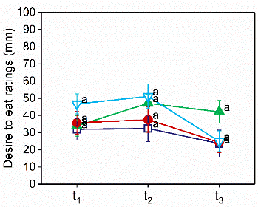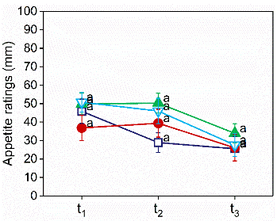

**a)**

**b)**

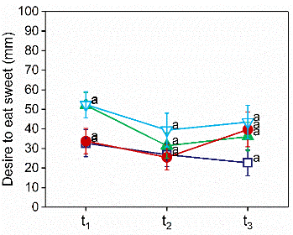

**c)**

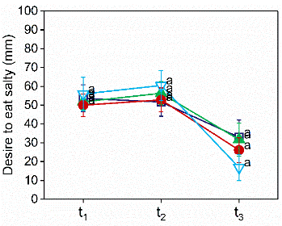

**d)**