Supplementary material

(b)
(a)
(c)
(d)
(e)
Figure S1. Dynamic DSC curves related to the evolution of the residual heat for A formulation after different curing times at 25°C: (a) 30 minutes, (b) 60 minutes, (c) 90 minutes, (d) 180 minutes and (e) 300 minutes.

(f)
(e)
(d)
(c)
(b)
(a)

Figure S2. Dynamic DSC curves related to the residual heat observed after curing overnight a sample from (a) A to (f) F formulations.

Figure S3. Dynamic TGA curves related to weight loss for final materials prepared from A to F formulations.

Figure S4. Dynamic TGA curves related to weight loss derivative for final materials prepared from A to F formulations.
Figure S5. tan delta and storage modulus comparison for each cured material prepared from A, B and C formulations with 1% DMT.

Figure S6. tan delta and storage modulus comparison for each cured material prepared from D, E, and F formulations with 0.75% DMT.
Figure S7. Dynamic DSC curve of Tg determination for commercial powder (POW).

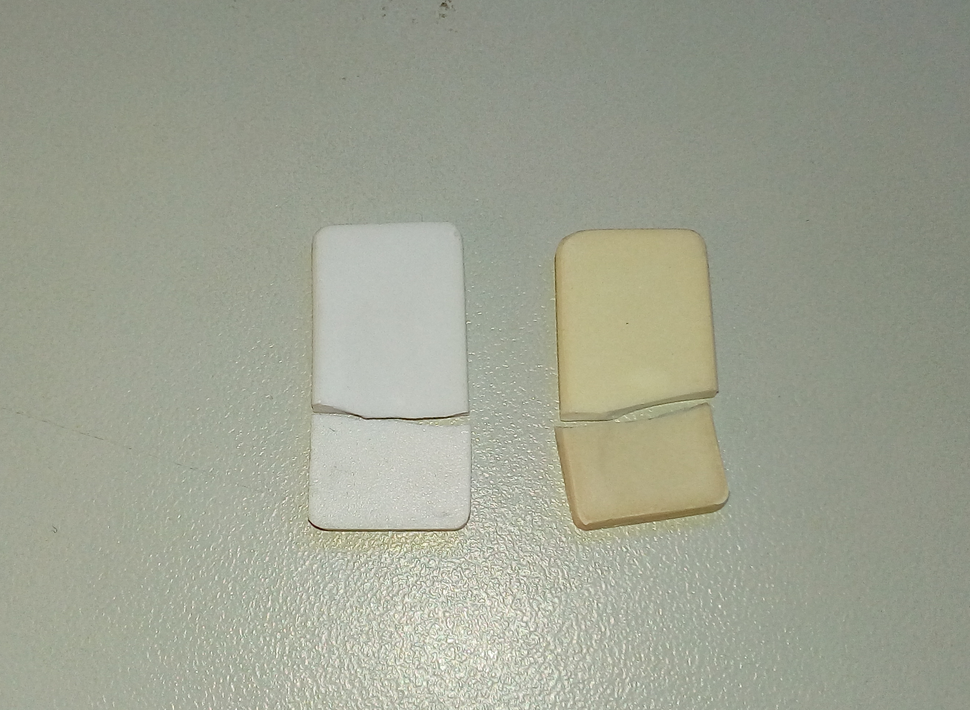
Figure S8. Pre-and post-aged samples of cured materials for impact tests.

