Supplementary Materials: Molecularly Imprinted Quartz Crystal Microbalance Sensor (QCM) for Bilirubin Detection
Çiğdem Çiçek, Fatma Yilmaz, Erdoğan Özgür, Handan Yavuz And Adil Denizli
(a)
(b)
Figure S1.
Figure S2. The contact angle values of (a) unmodified (bare) QCM; (b) MIP-QCM; and (c) NIP-QCM surfaces.
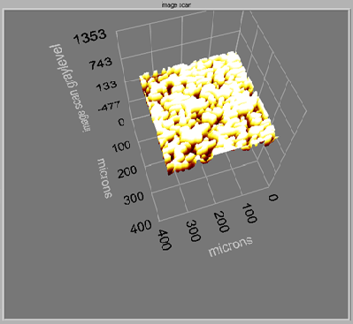  (A) | 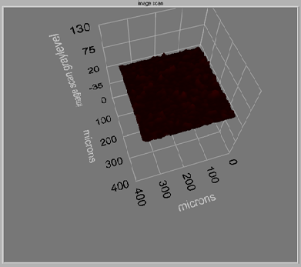  (B)
Figure S3. Morphology of QCM sensor surfaces observed with ellipsometer: (A) MIP-QCM; (B) NIP-QCM.

Figure S4. Reproducibility of QCM sensor response for different sensor batch produced at different times; concentration of bilirubin: 1µg/mL; buffer; pH:11 carbonate buffer.

